**TASK - Full AWS layer 3 architecture**

**Description -used create VPC , subnets , internet gateway , routing table , security group , key pair, EC2 instance , apache server http , application load balancer, auto scaling group, Relational database service , installed MYSQL.**

**- Virtual Private Cloud (VPC)**

**VPC** – Amazon Virtual Private cloud (amazon VPC) enables you to launch Aws resources into a virtual network that you have defined and It is virtual network or data center inside of AWS for one client and It is logical isolated from other virtual network in the AWS cloud .

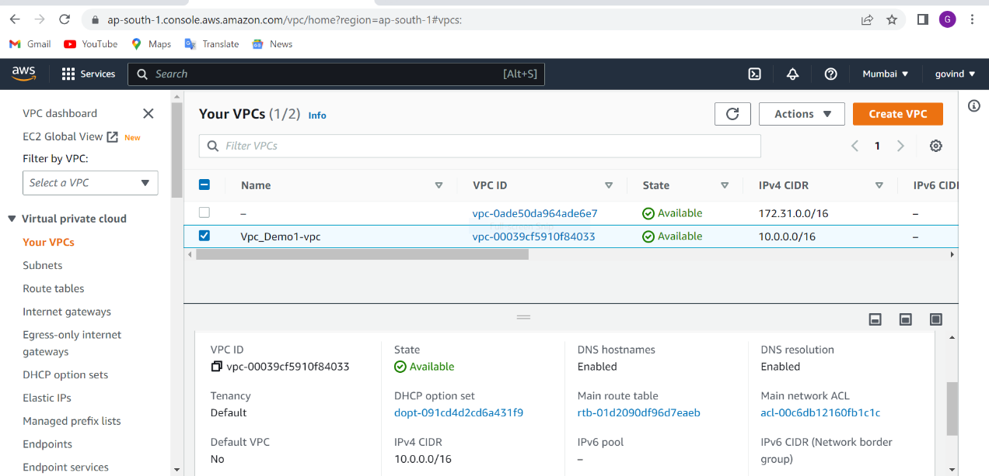

**Subnets** – a subnet is a range of IP addresses in your VPC and public subnet it is used to connect to internet gateway.

1). Public subnets 2). Private subnets

We have to connect public IP with internet gateway we use public Subnet

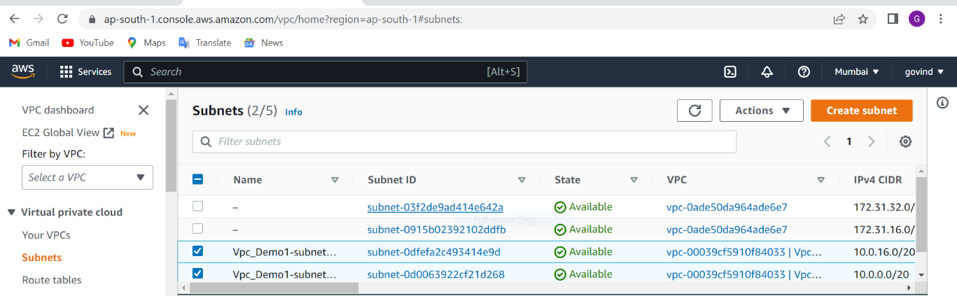

Internet gateway – ­­­­ internet gateway is a virtual router that connects a VPC to the internet

we will attach VPC . Virtual server will be connected with internet that’s why we use internet gateway

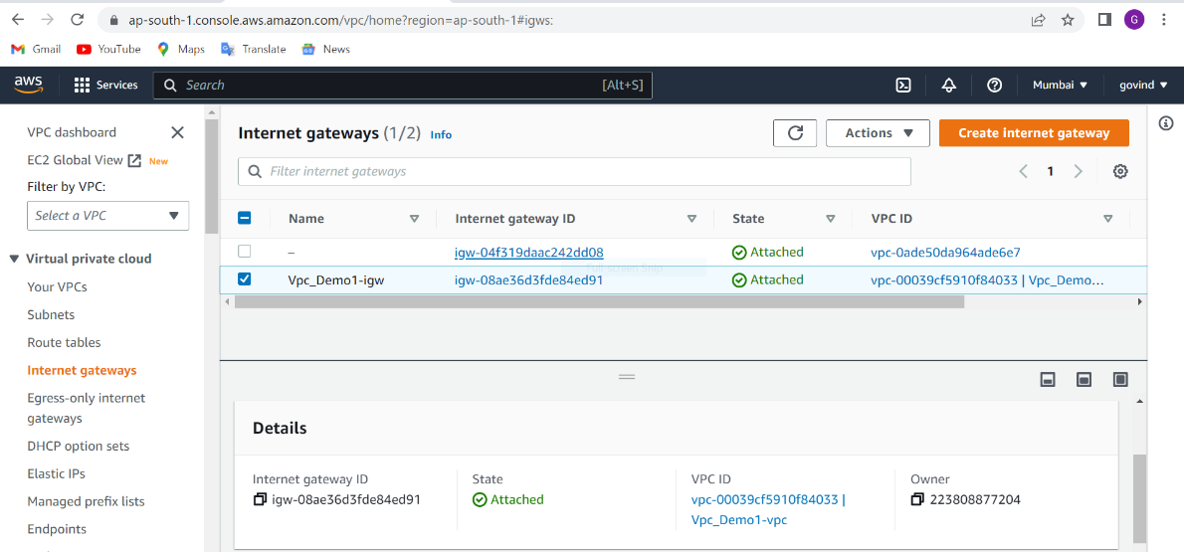

Router – we will add a route for the internet gateway to this custom route table.

Subnet association – we have to route . we will connect subnets with routing table

When we have to go on internet gateway then we will connect to internet

Example:

Subnet – 10.0.0.0/16 -----🡪 0.0.0.0

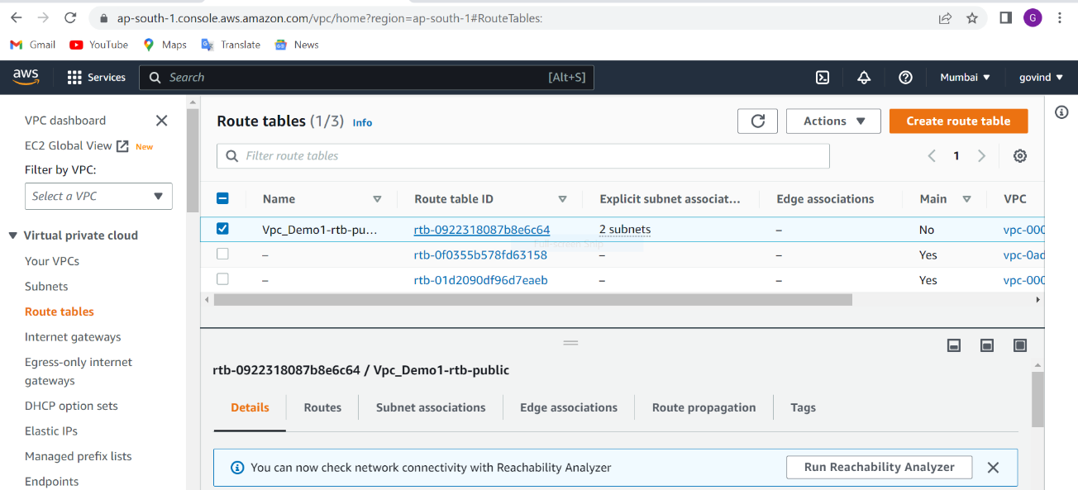

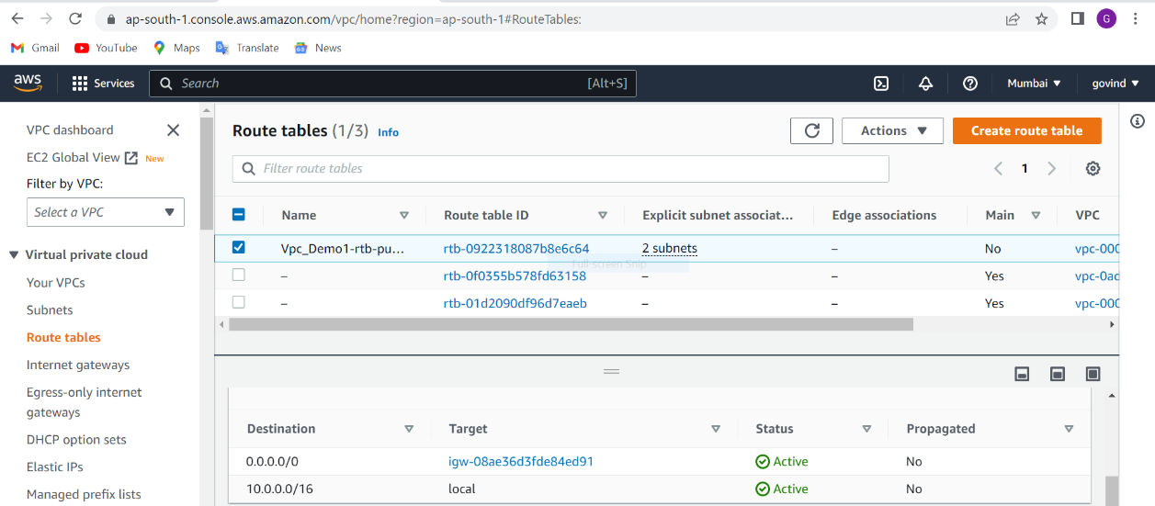

EC2 instance -> It is Elastic compute cloud. Amazon provide scalability computing capacity in the aws cloud it is amazon web service you use to create and run virtual machines in the cloud.

  You can use Amazon EC2 to launch as many or as few virtual servers as you need, configure security and networking, and manage storage.

First, you need to get set up to use Amazon EC2. After you are set up.

We have taken free t2.micro linux server to work on server

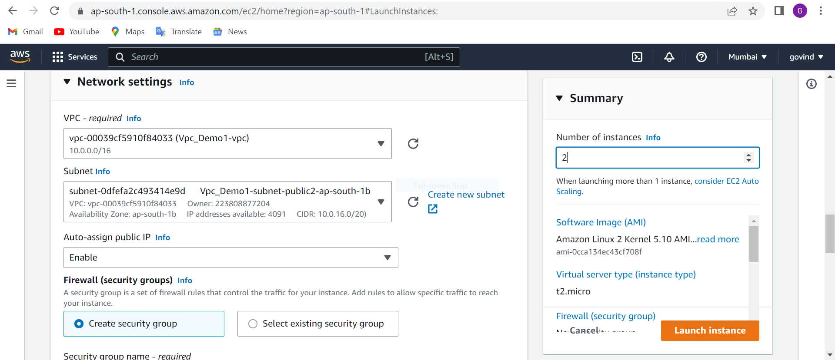

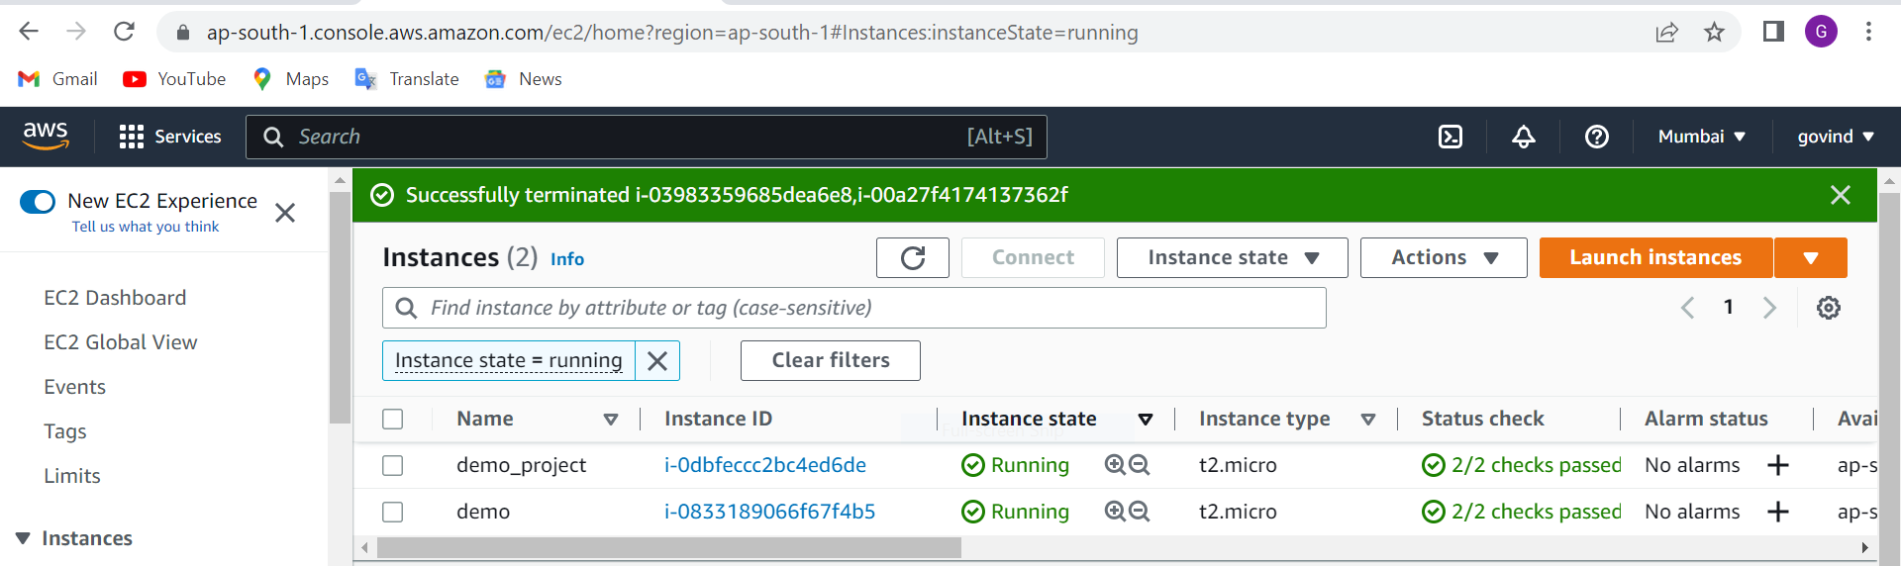

**Launch templates**- it is used that use launch templates to automate instance launches, simplify permission policies , and enforce best practices across your organization. Save launch parameters in a template that can be used for on-demand launches and with managed services, including EC2 fleet. Easily update your launch parameters by creating a new launch template

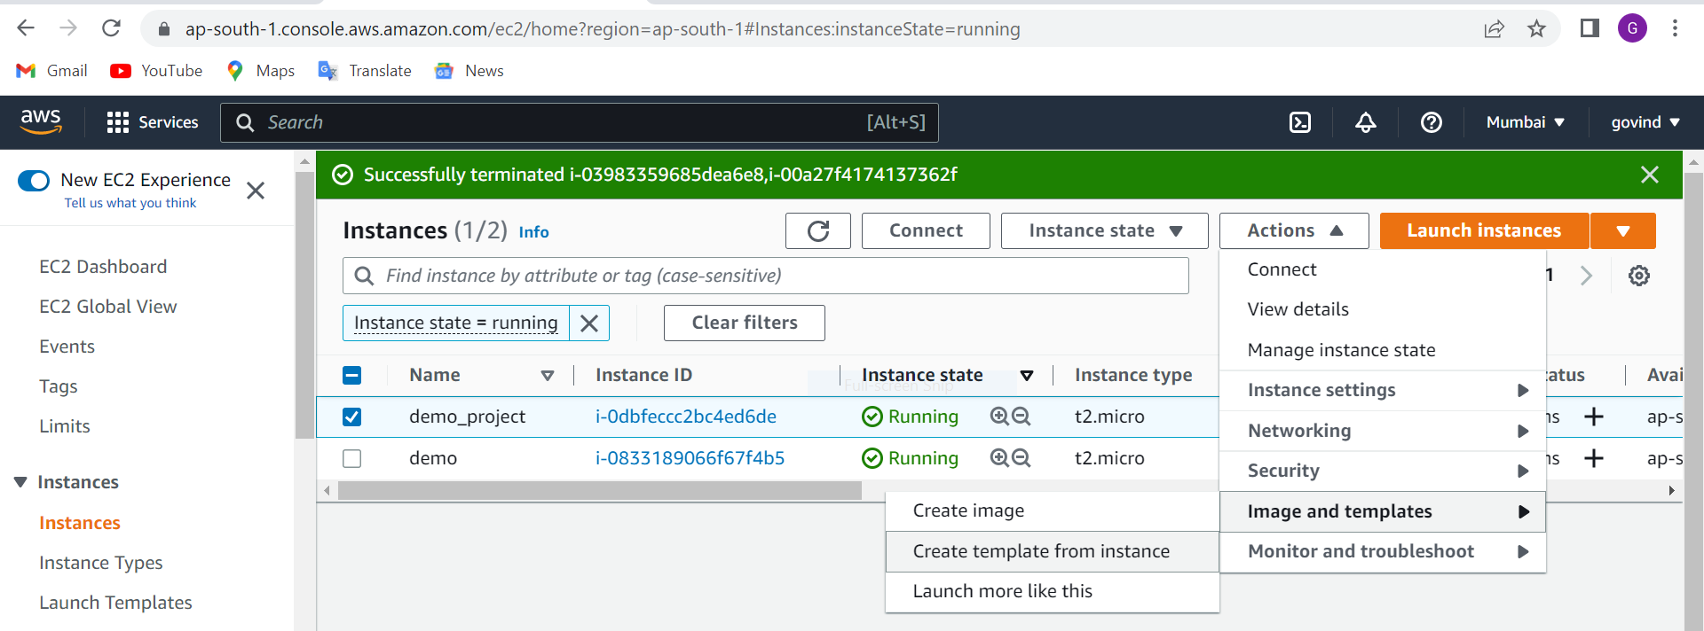

Security group – we used security group of allowing traffic

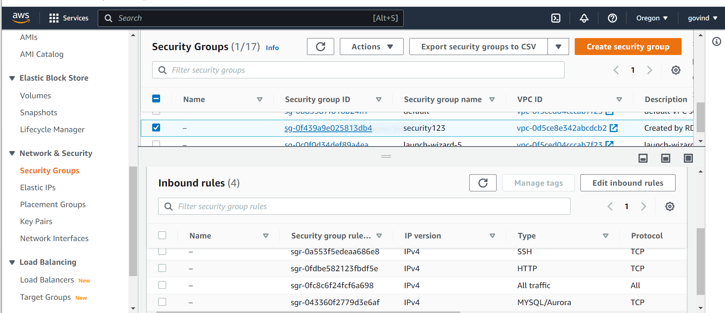

**- Installed apache web server**

sudo yum update –y // update the packages

sudo yum install -y httpd.x86_64 // installed httpd server

sudo systemctl start httpd.service // for starting the all services

sudo systemctl enable httpd.service //for enable the all

sudo systemctl status httpd.server // checking the status

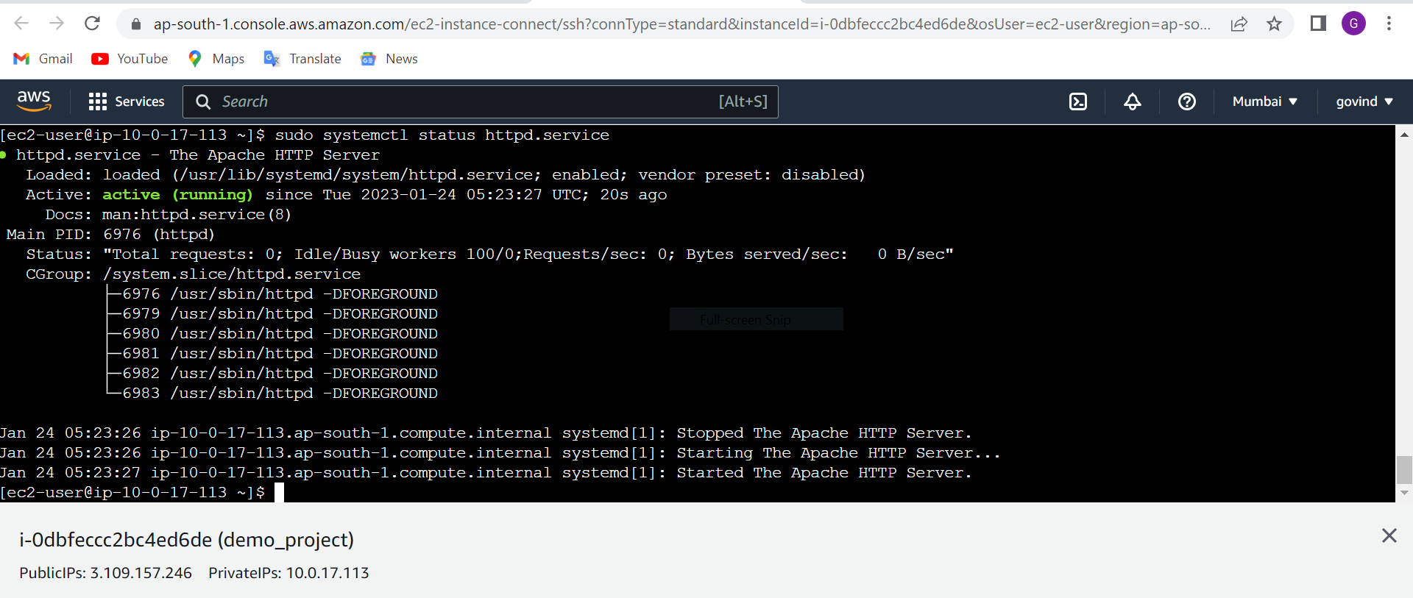

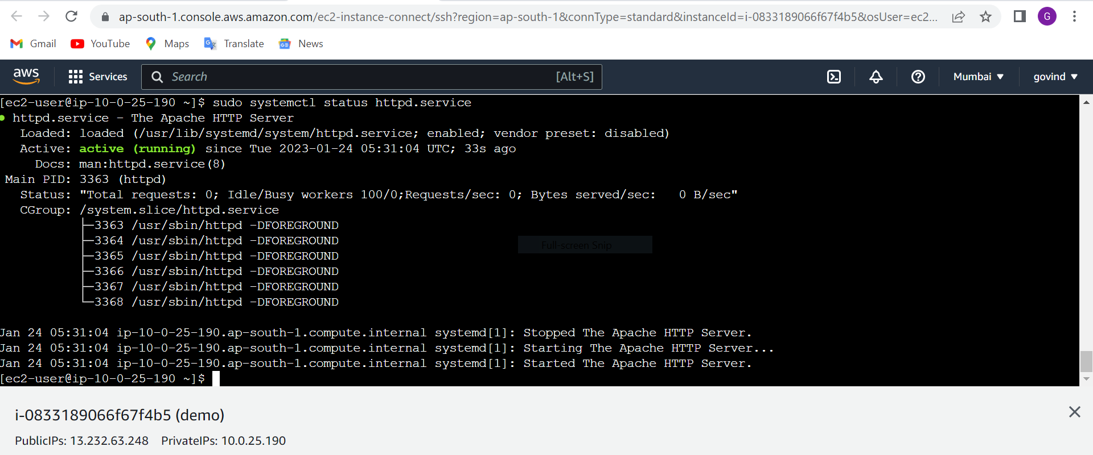

sudo nano /var/www/html/index.html // for adding the html code we want to see hello Team on browser.

<!DOCTYPE html>

<html>

<body>

<h1>Hello Team!!</h1>

<p>Welcome to demo_project</p>

</body>

</html>

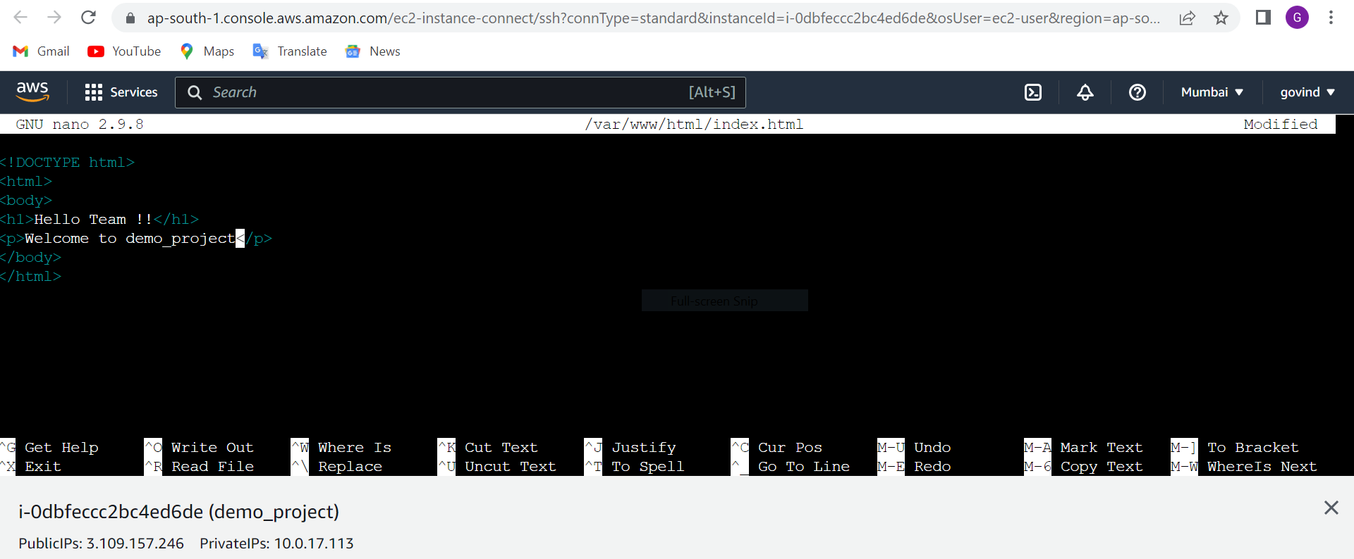

We can access the data through the browser http://3.109.157.246

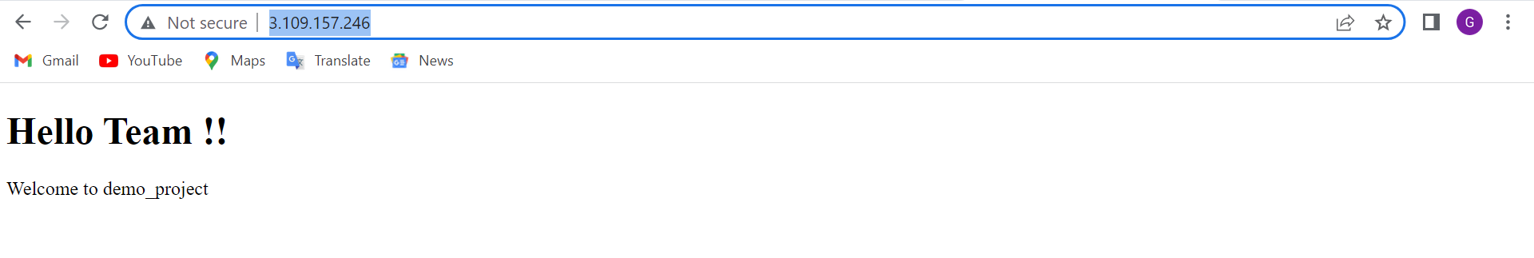

sudo nano /var/www/html/index.html // for adding the html code in other server we want to see hello Team on browser.

<!DOCTYPE html>

<html>

<body>

<h1>Hello Team2!!</h1>

<p>Welcome to demo server</p>

</body>

</html>

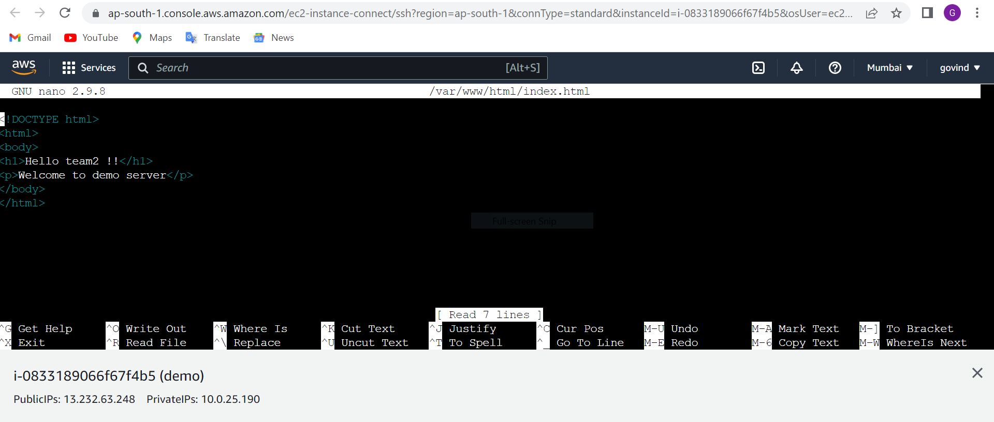

We can access the data through the browser http://13.232.63.248

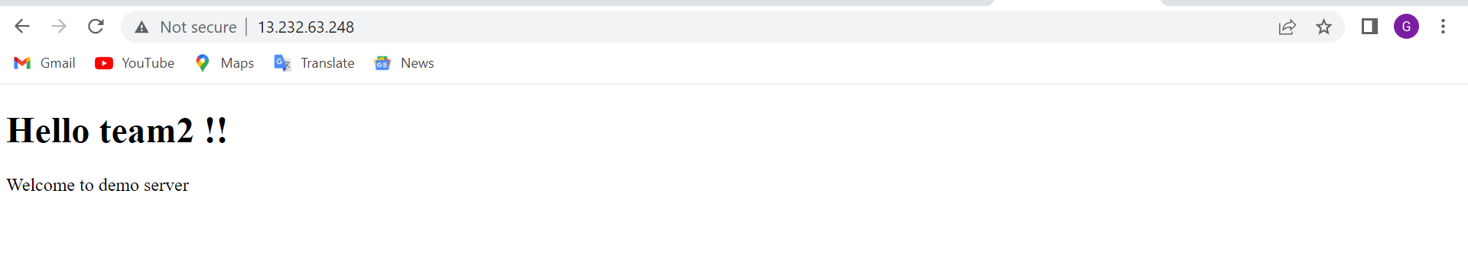

**Application load balancer**

Application Load Balancing automatically distributes your incoming traffic across multiple targets, such as EC2 instances, containers, and IP addresses, in one or more Availability Zones. It monitors the health of its registered targets, and routes traffic only to the healthy target

A load balancer serves as the single point of contact for clients. The load balancer distributes incoming application traffic across multiple targets, such as EC2 instances, in multiple Availability Zones. This increases the availability of your application. You add one or more listeners to your load balancer.

**Target groups for your Application Load Balancers** ... Each target group is used to route requests to one or more registered targets. When you create each listener and it will balance of load

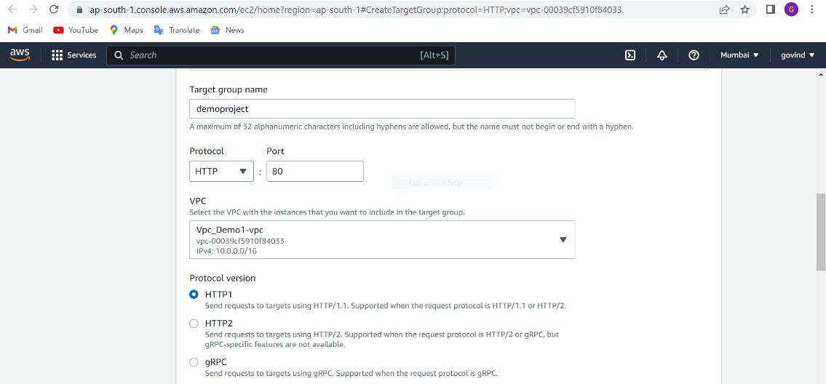

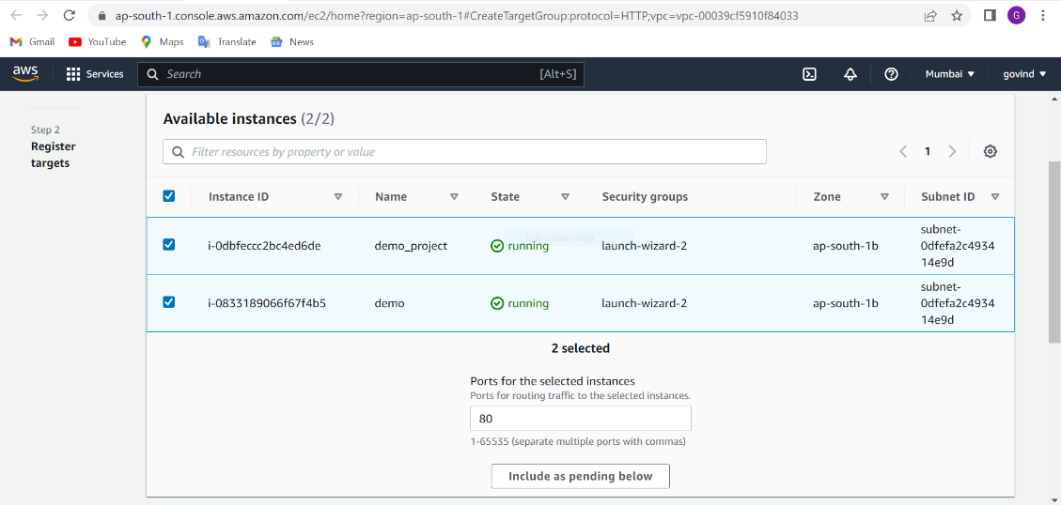

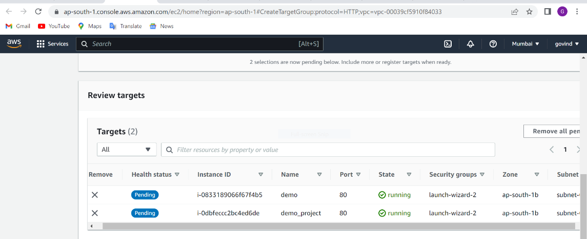

It will check healthy targets suppose target is healthy so it will convert the traffic otherwise it will not send the traffic.

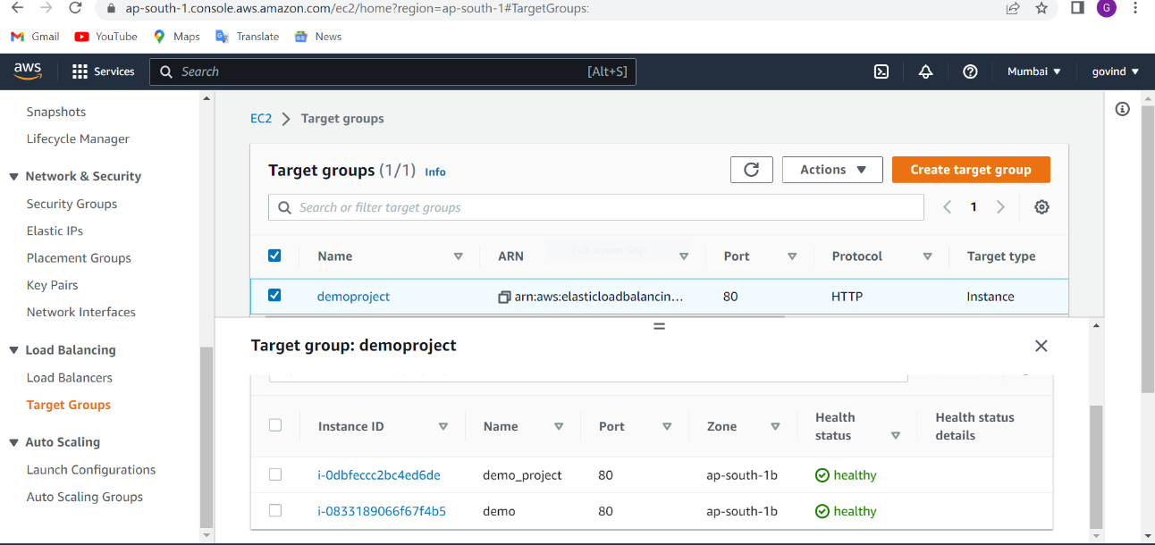

Now we will create application load balancer

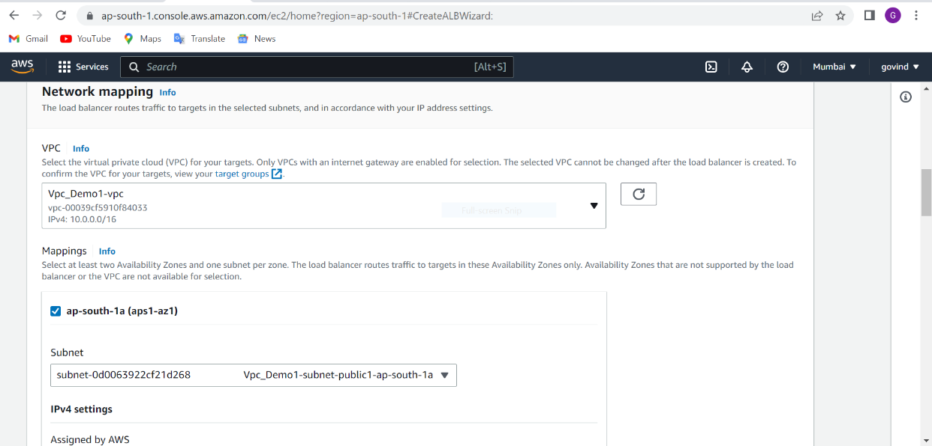

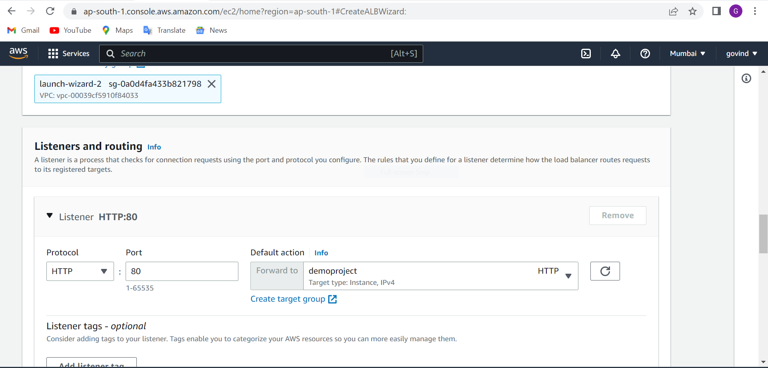

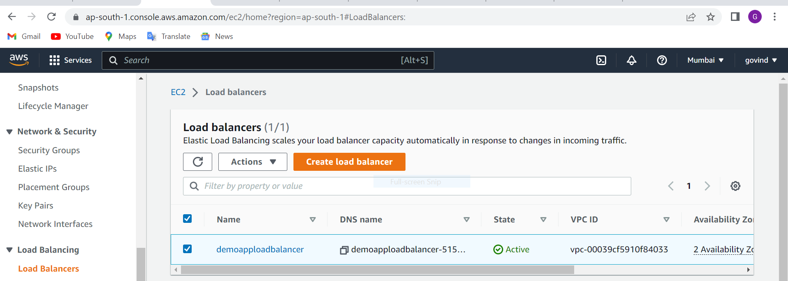

After we can see that how can jump the traffic on the browser on DNS http://demoapploadbalancer-515484433.ap-south-1elb.amazonaws.com

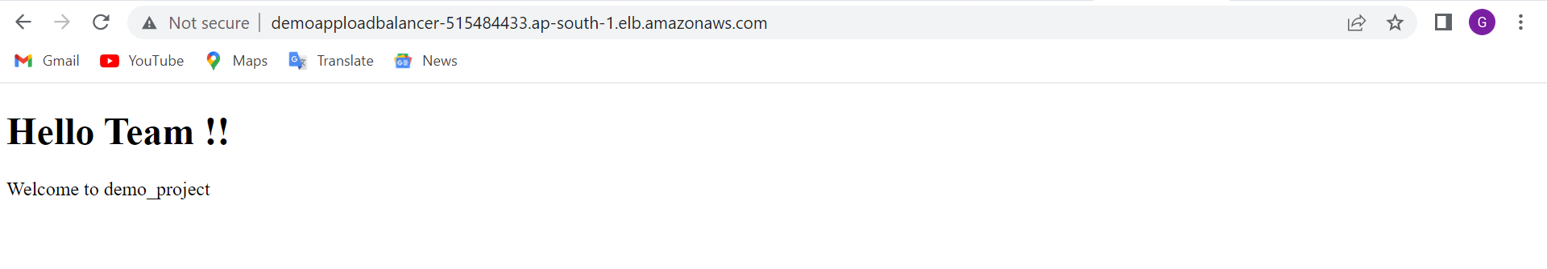

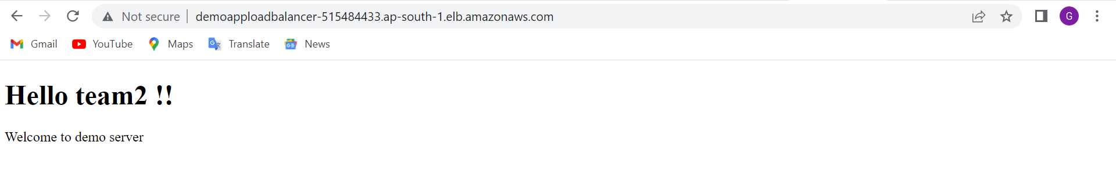

**Autoscaling group**

1). Launch templates—launch templates enables you to store the parameter ( ami , instance type security group and key pairs)

We have created template from instance

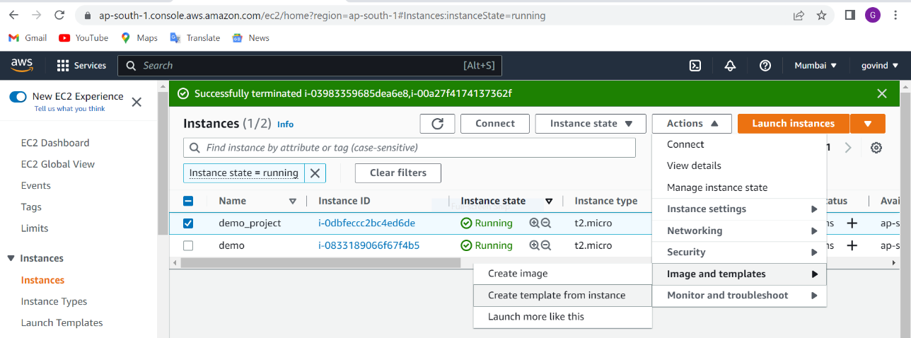

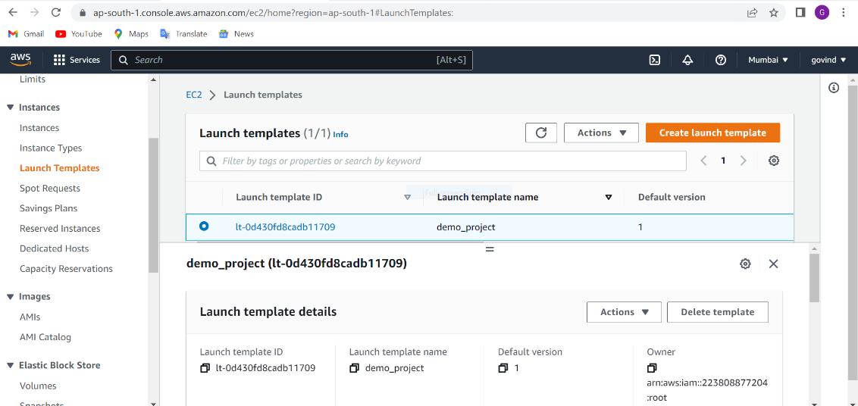

Auto scaling - it provides users with an automated approach to increase or decrease the instance according to traffic whatever we have defined the rule

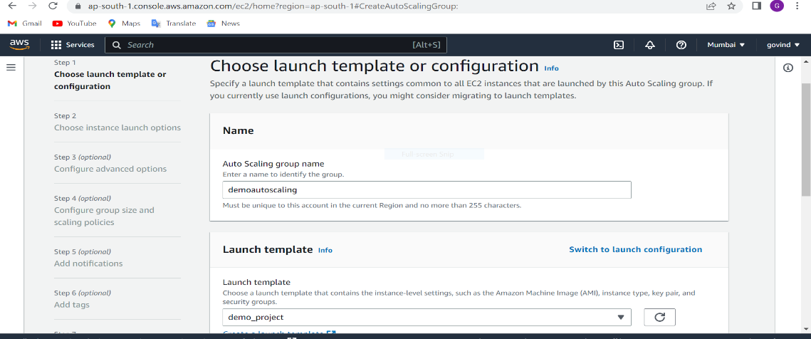

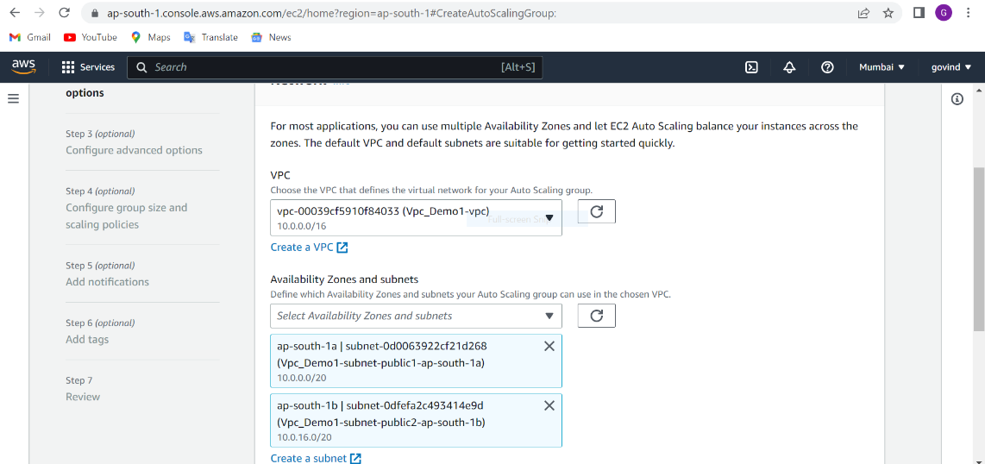

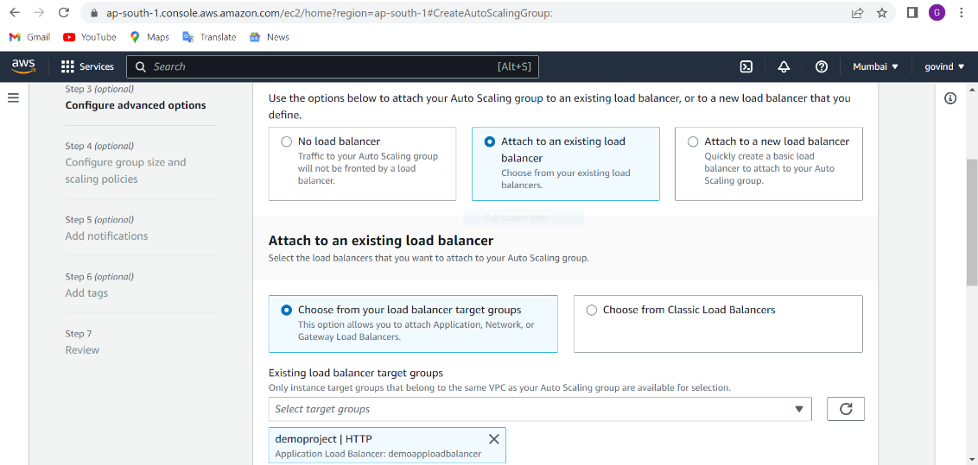

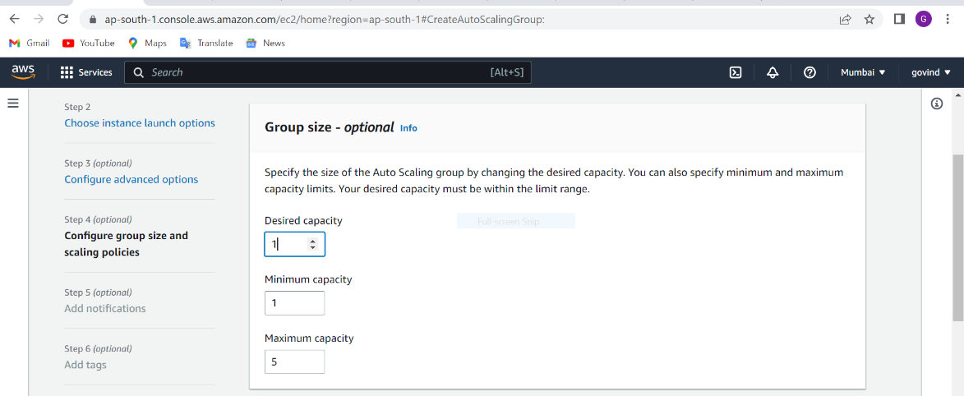

After that we will create scaling policy.

**Simple notification service –** Amazon SNS and Amazon Cloud Watch are integrated so you can collect, view, and analyze metrics for every active Amazon SNS notification. Once you have configured Cloud Watch for Amazon SNS, you can gain better insight into the performance of your Amazon SNS topics, push notifications, and SMS deliveries.

Create

1). Topic🡪 who do you want to send alerts through like : SQS, SMS, email, mobile application

2). Subscriptions🡪 we will give subscription for sending alerts like SMS , Email.

And we will confirm for sending alerts through Email.

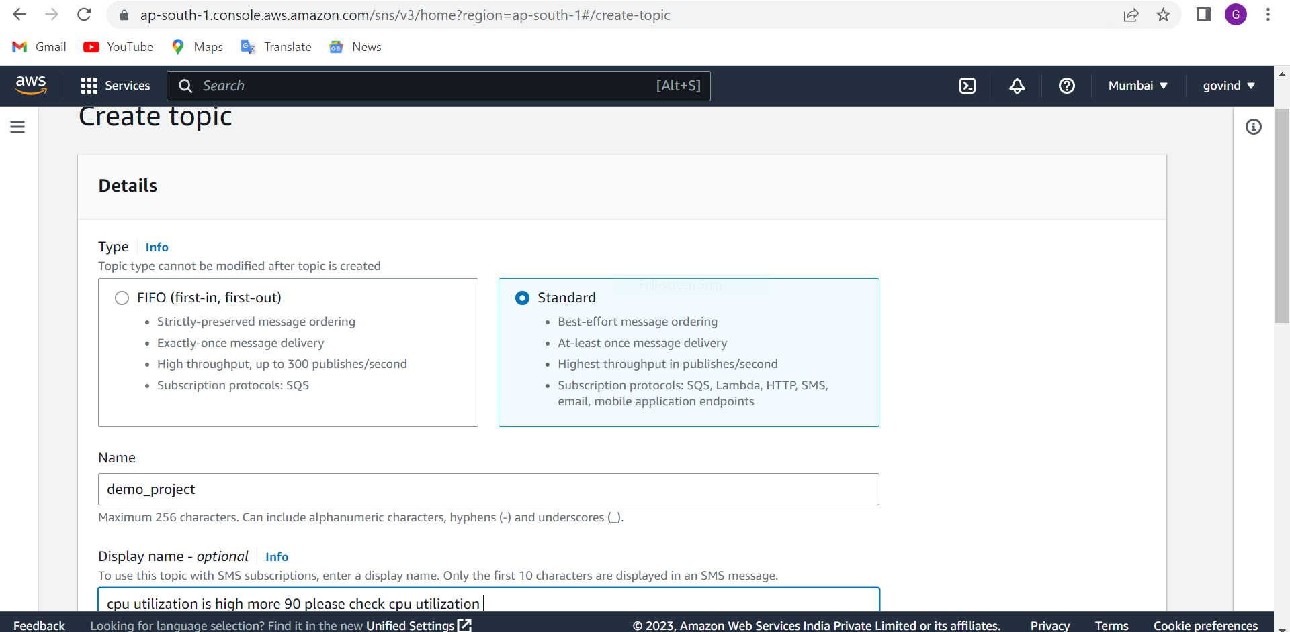

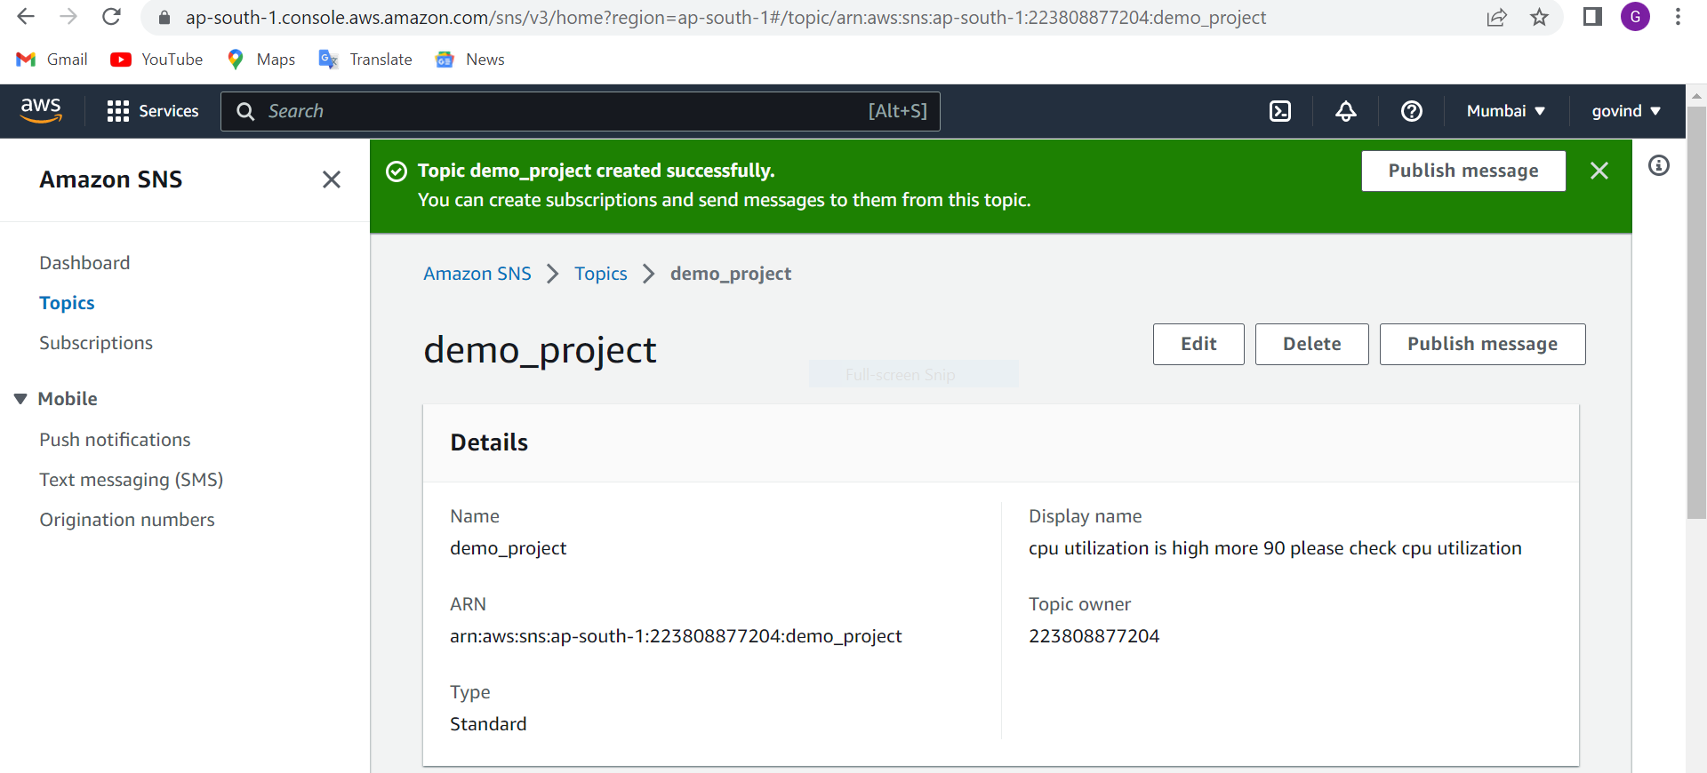

2). Subscriptions🡪 we will give subscription for sending alerts like SMS , Email.

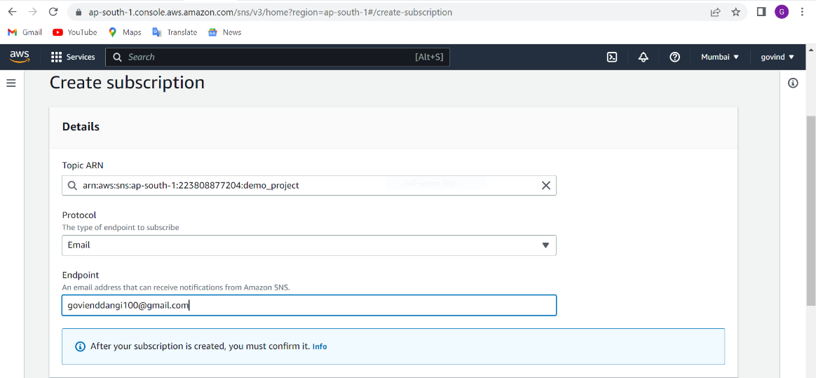

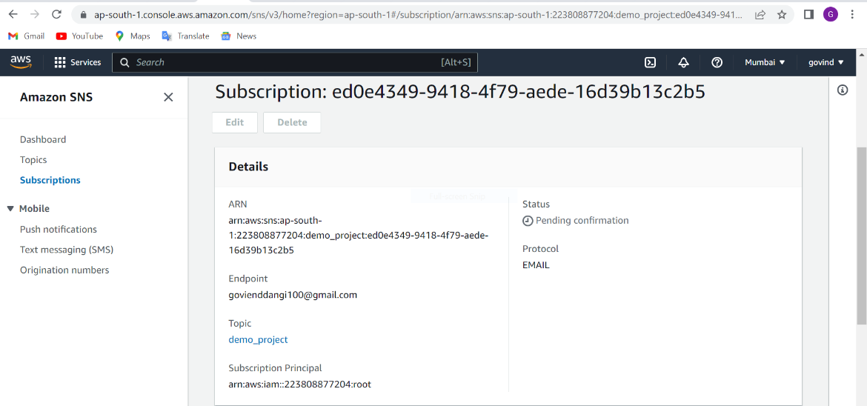

We can see mail for subscription

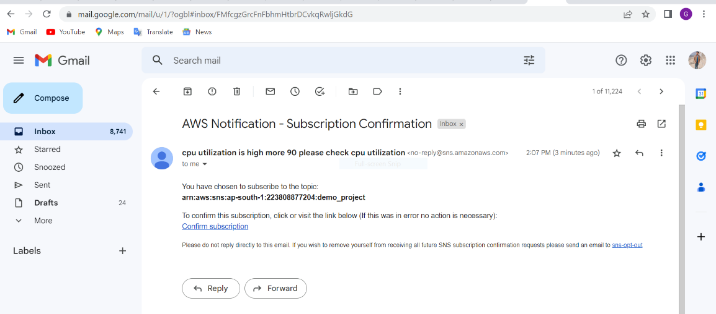

We have given the conformation for subscription

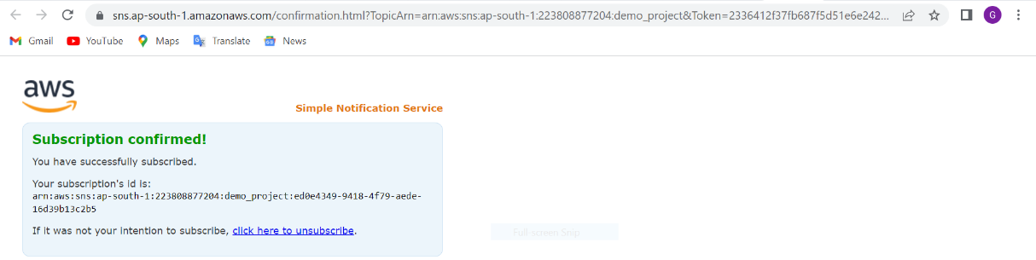

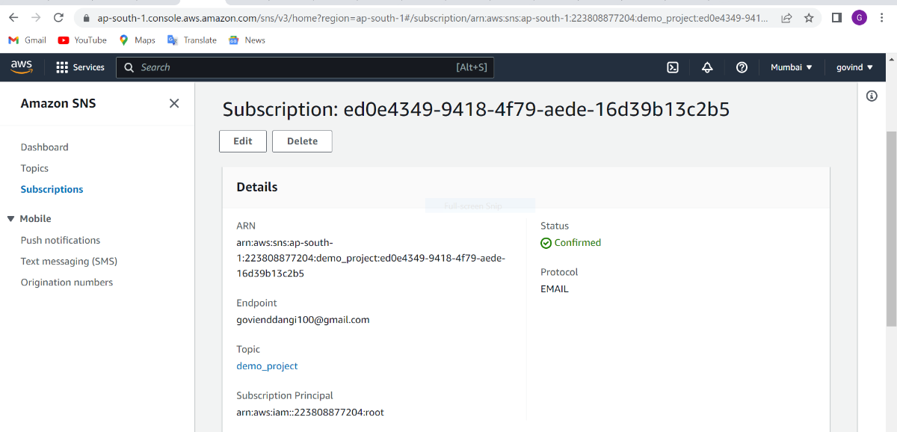

**cloud watch** – you can use amazon cloud watch logs to monitor, store and access your logs files from amazon ec2

Cloud Watch collects monitoring and operational data in the form of logs, metrics, and events, and visualizes it

1). Alarm. We have created rule suppose CPU utilization is greater than 90 (>=90) it will check the server till 5 minutes then it will take action it will send notification in the email (CPU Utilization >= 90 for 1 data points within 1 minutes) In Createserver1 So server will be added in two minutes

We set scale policy and we have created cloud watch for scale out

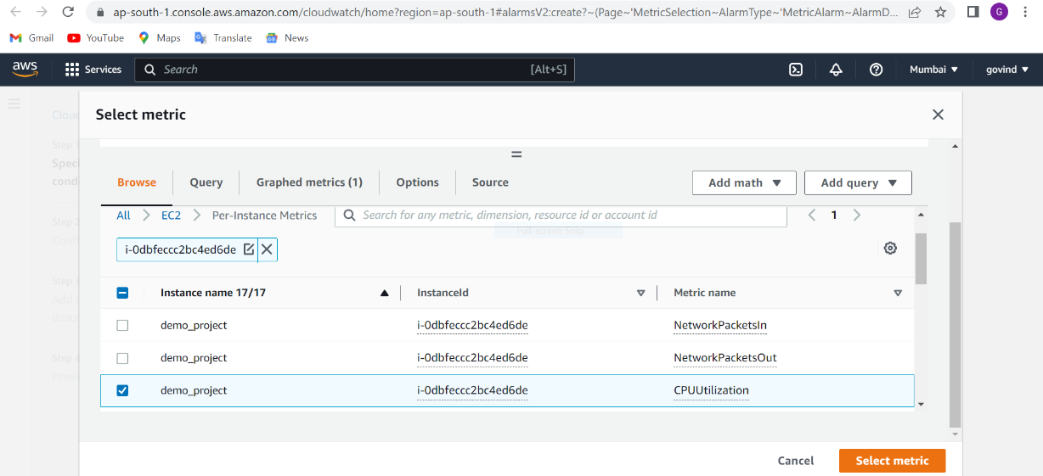

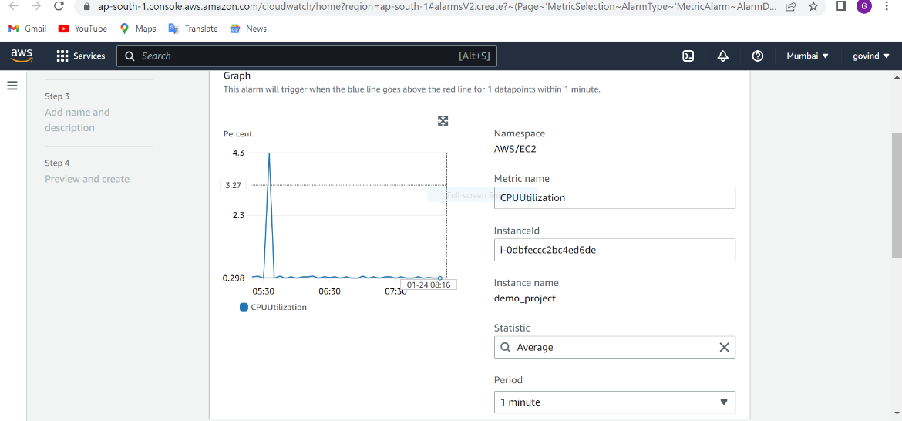

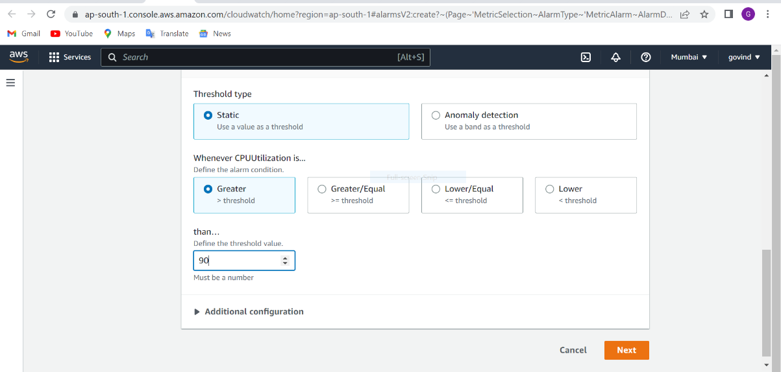

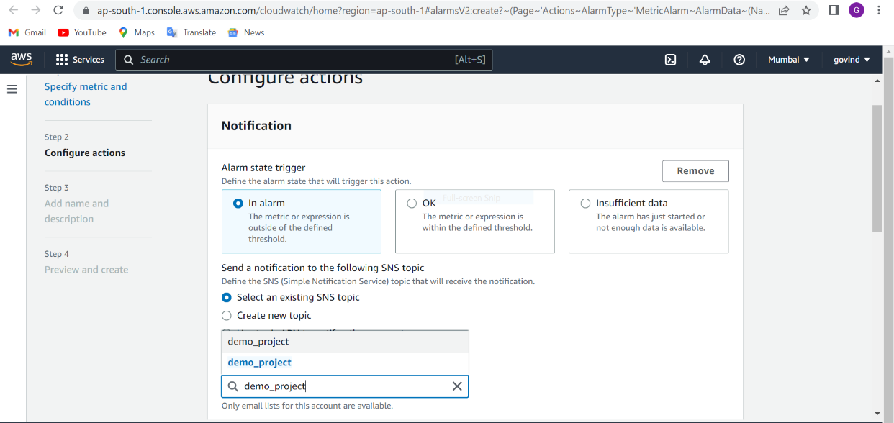

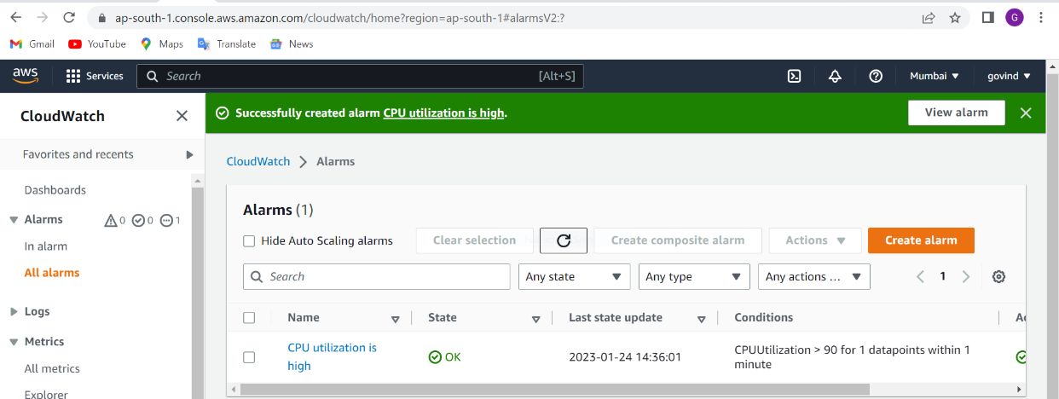

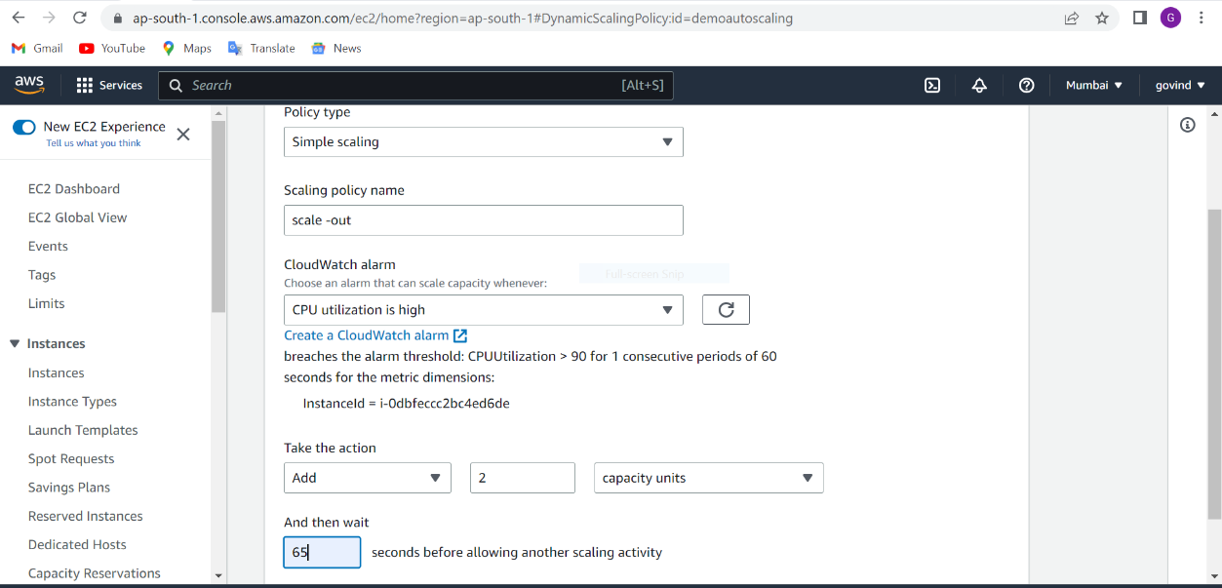

We can check the CPU utilization.

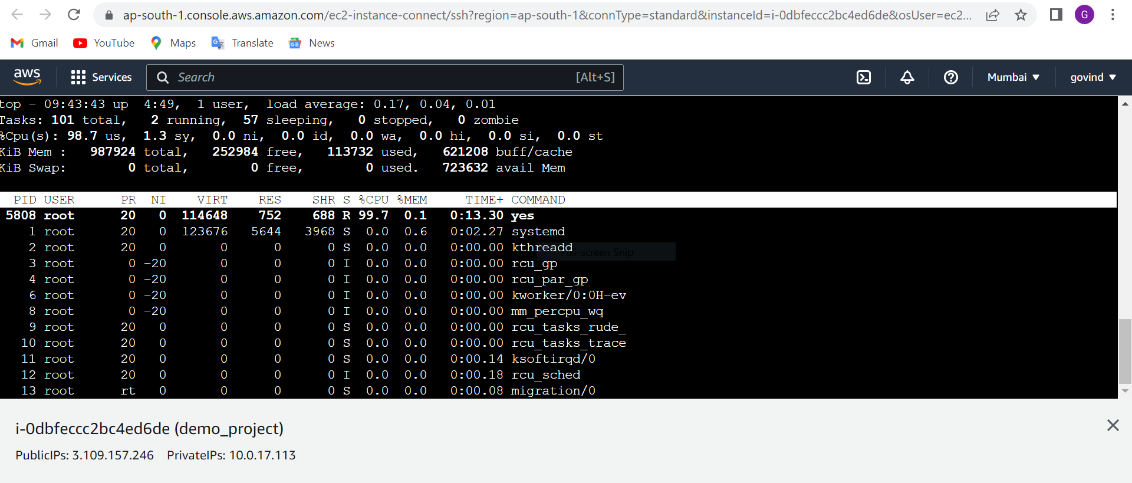

We can check the notification according to the condition in mail , whatever we have defined the condition.

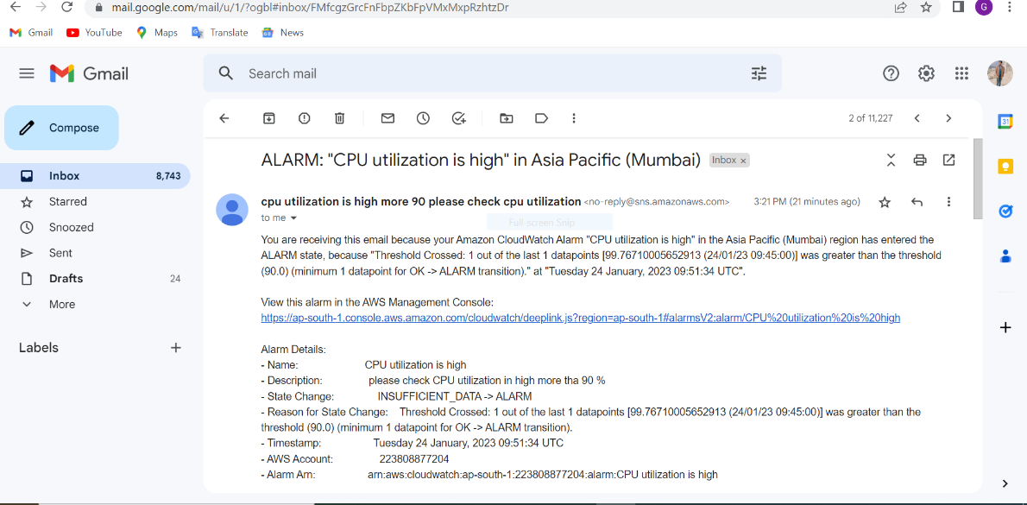

When CPU utilization is more than 90 so Alarm is triggered, that’s why it will add 2 instances of demo_project.

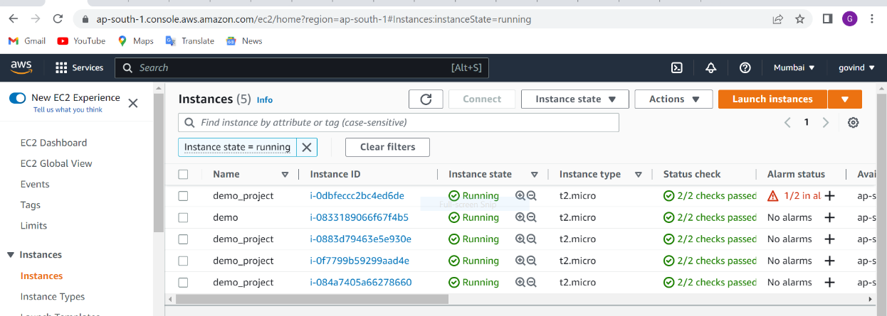

We set scale policy and we have created cloud watch for scale in

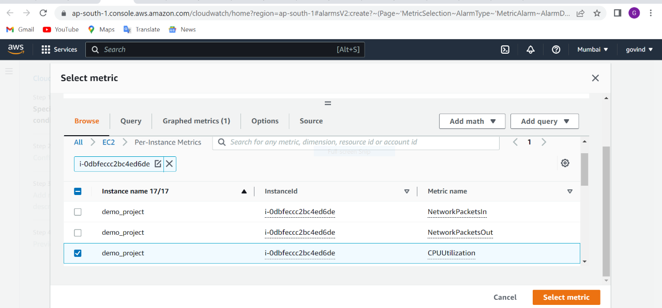

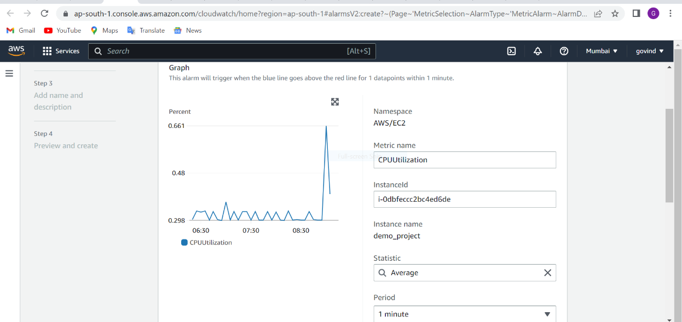

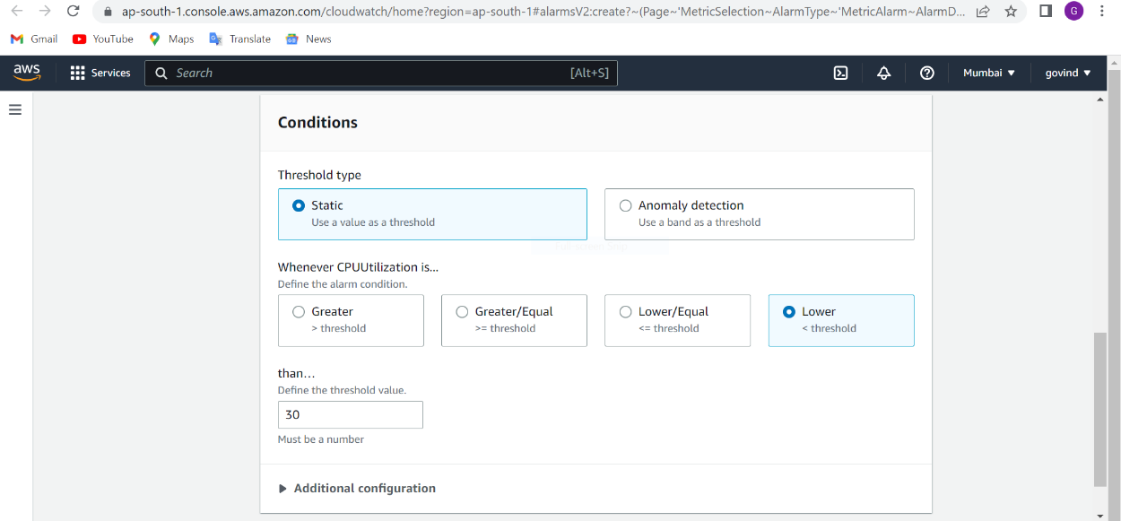

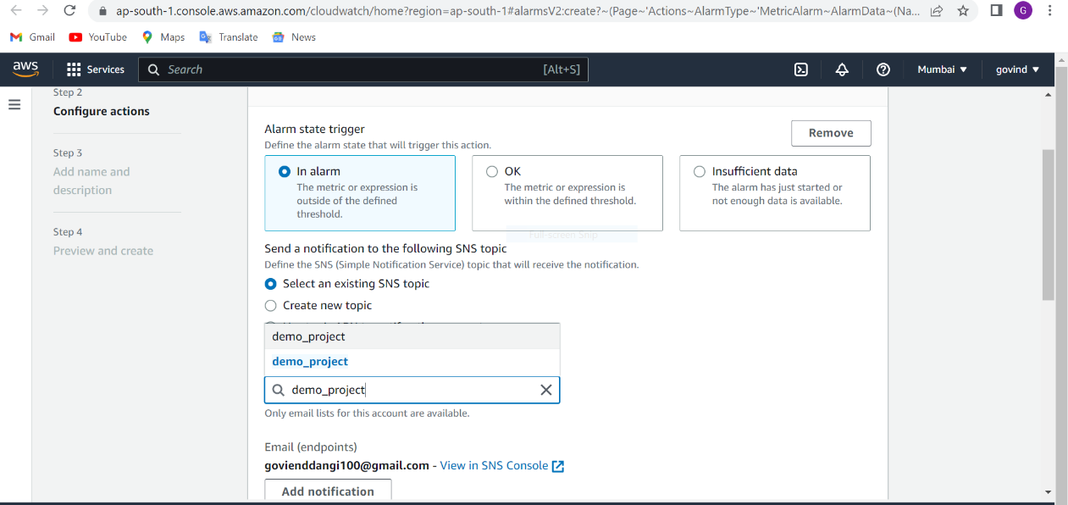

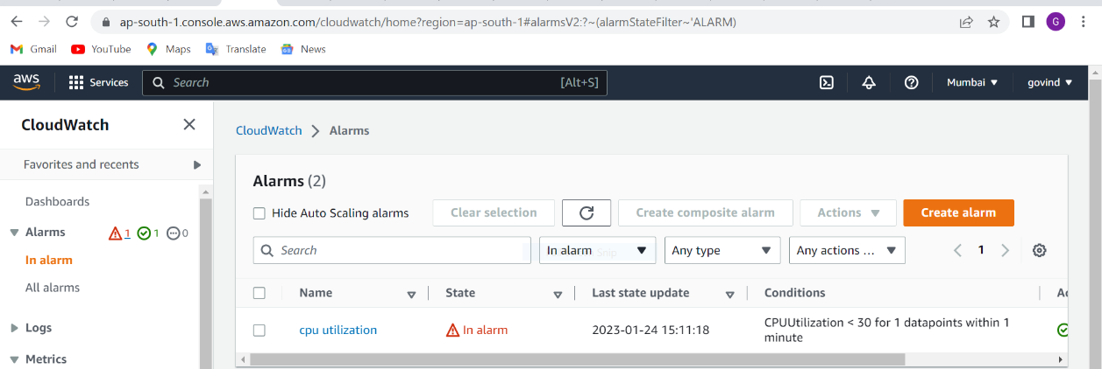

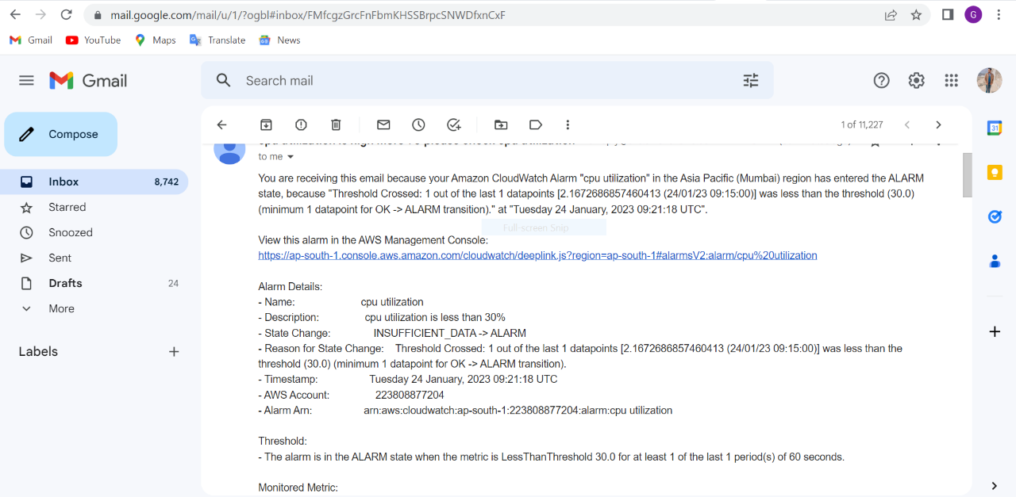

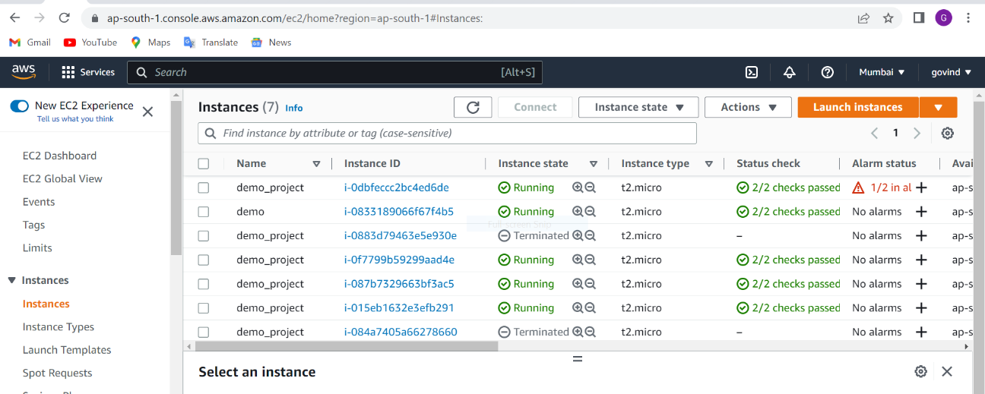

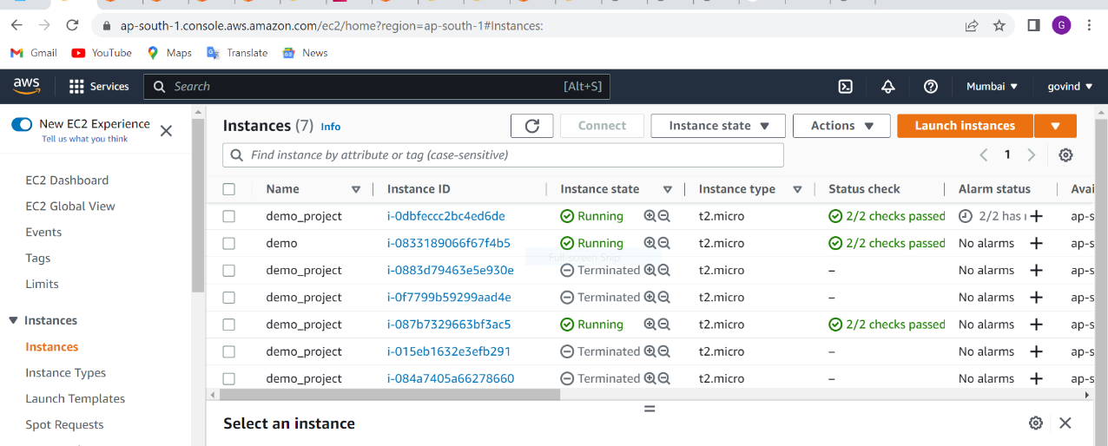

**- Relational Database Service**

RDS – it is relational database service it is used to store the data in form of tables . in aws fully managed relational DS engines service where aws is responsible for automatic backup, patching ,security purpose that’s important

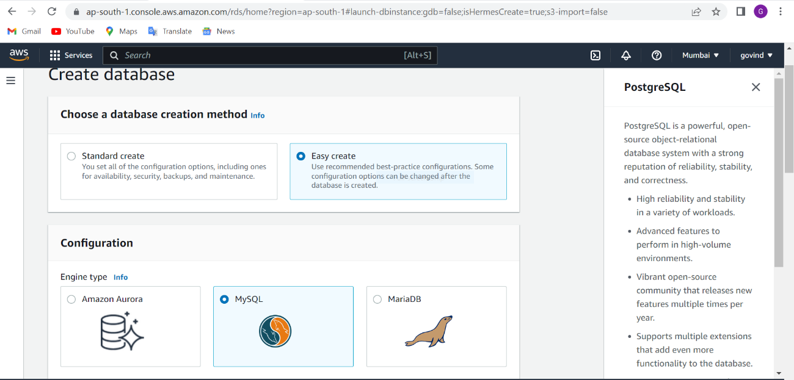

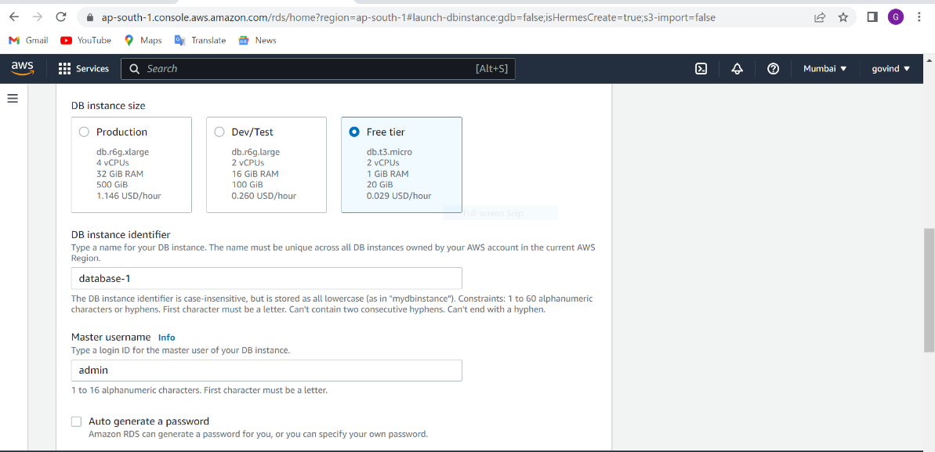

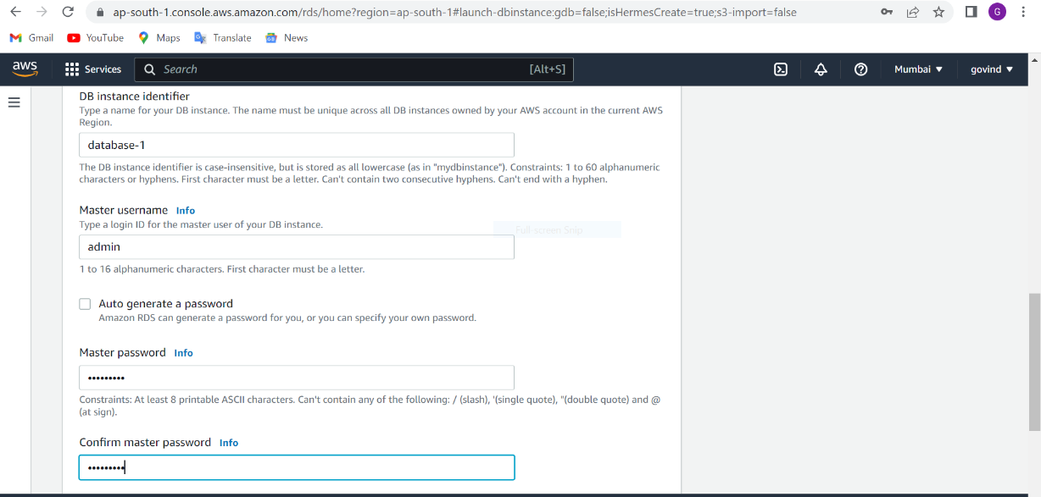

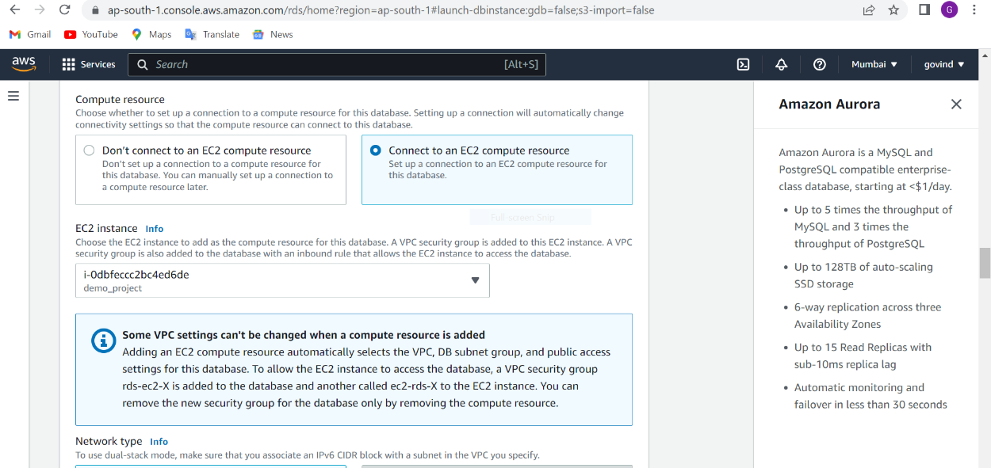

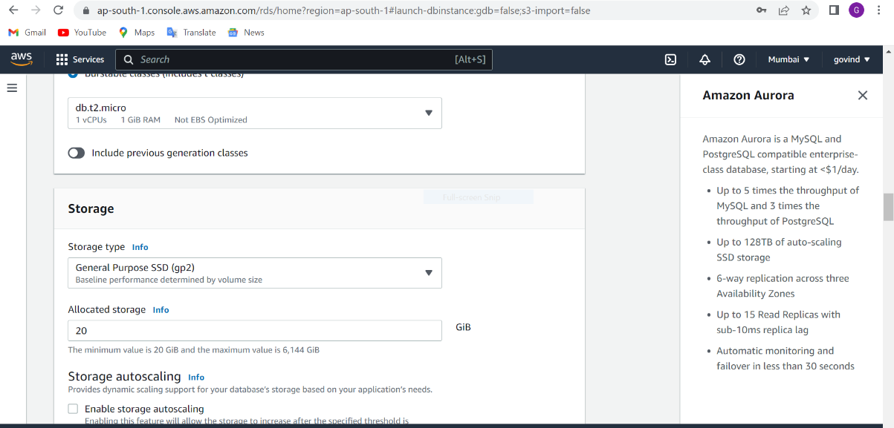

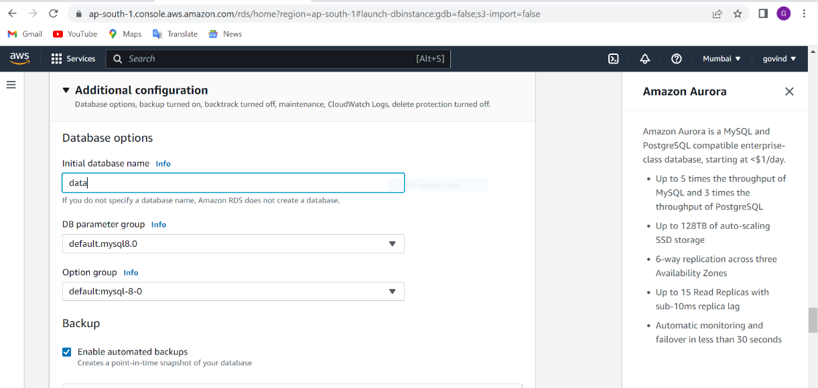

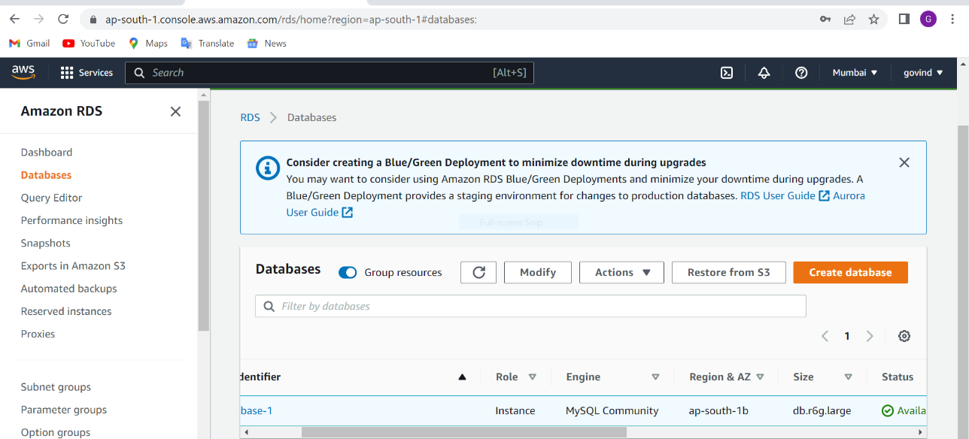

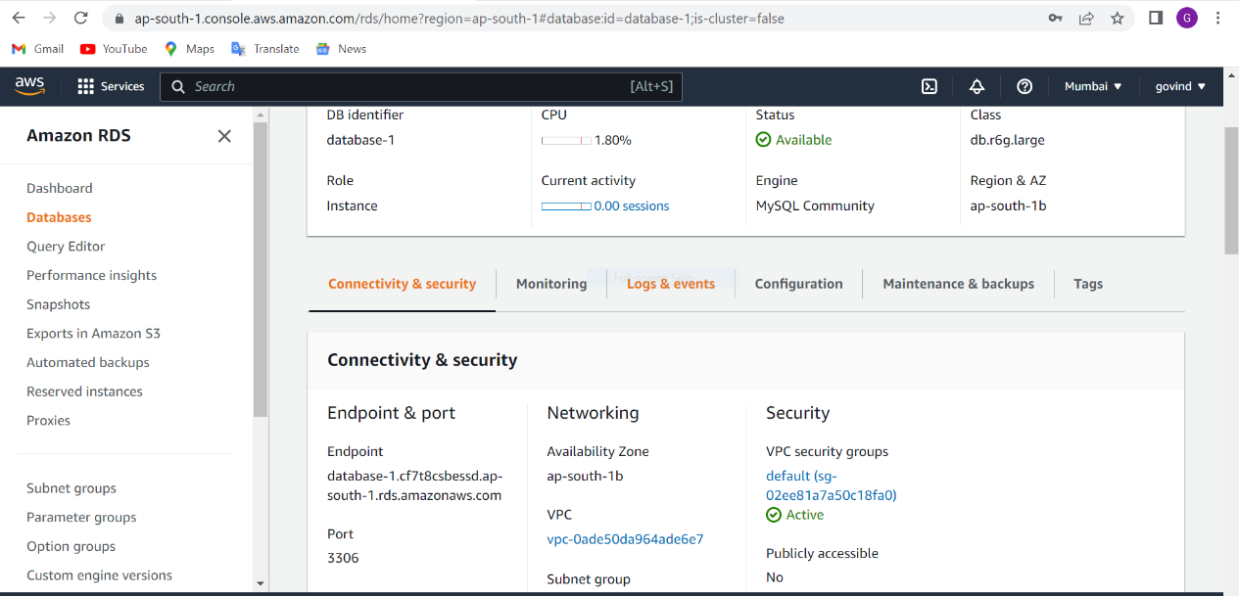

We have installed SQL in demo_project

SQL – sql is the standard language for dealing with Relational Database .SQL can be used to insert, search, update, and delete database records. SQL can do lots of operations, including optimization and maintenance of database.

We have used for MYSQL installation on EC2 instance

sudo su – for root user

yum install –y mysql for installation

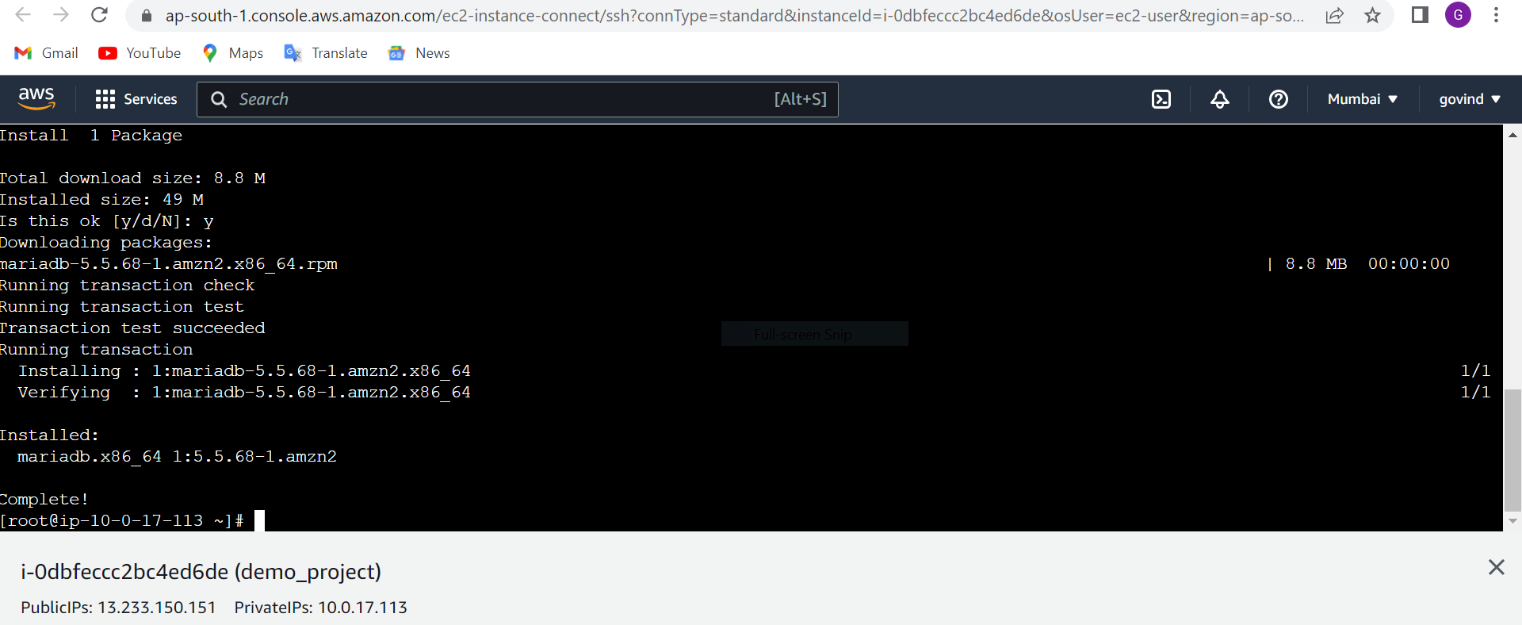

mysql -h database-1.cf7t8csbessd.ap-south-1.rds.amazonaws.com -p data -u admin // it is used to connect with RDS

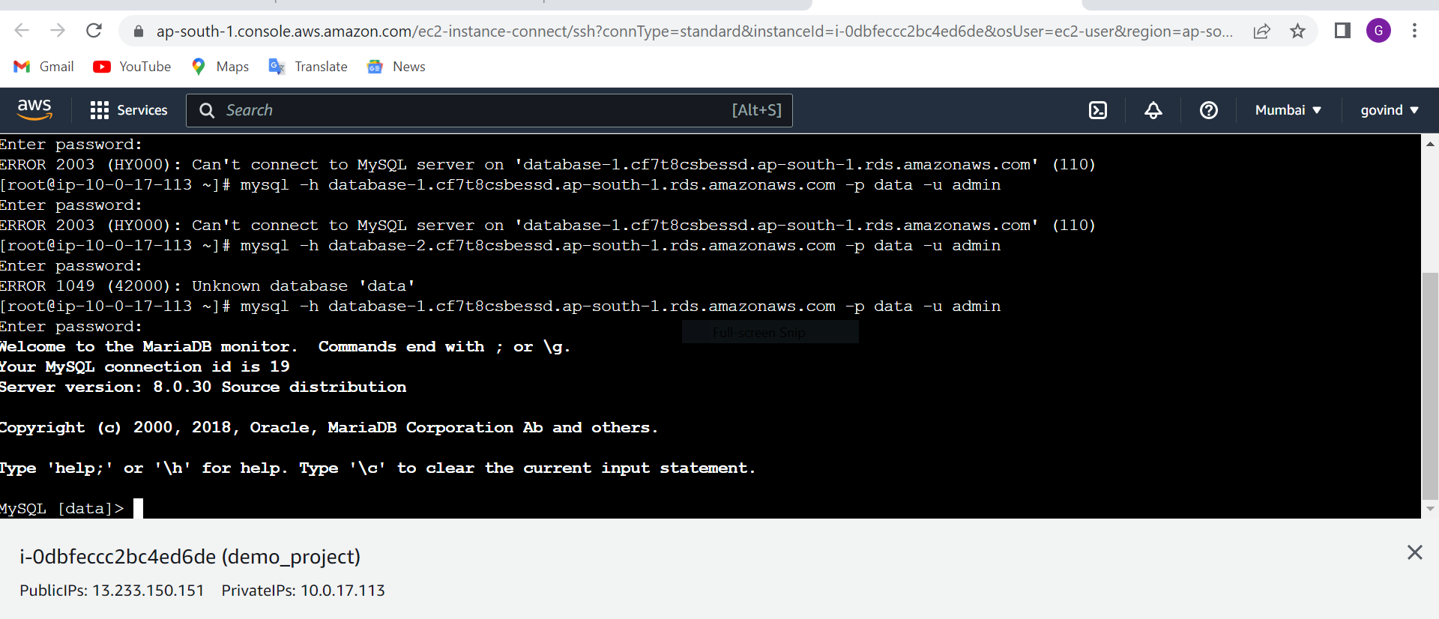

Show databases;

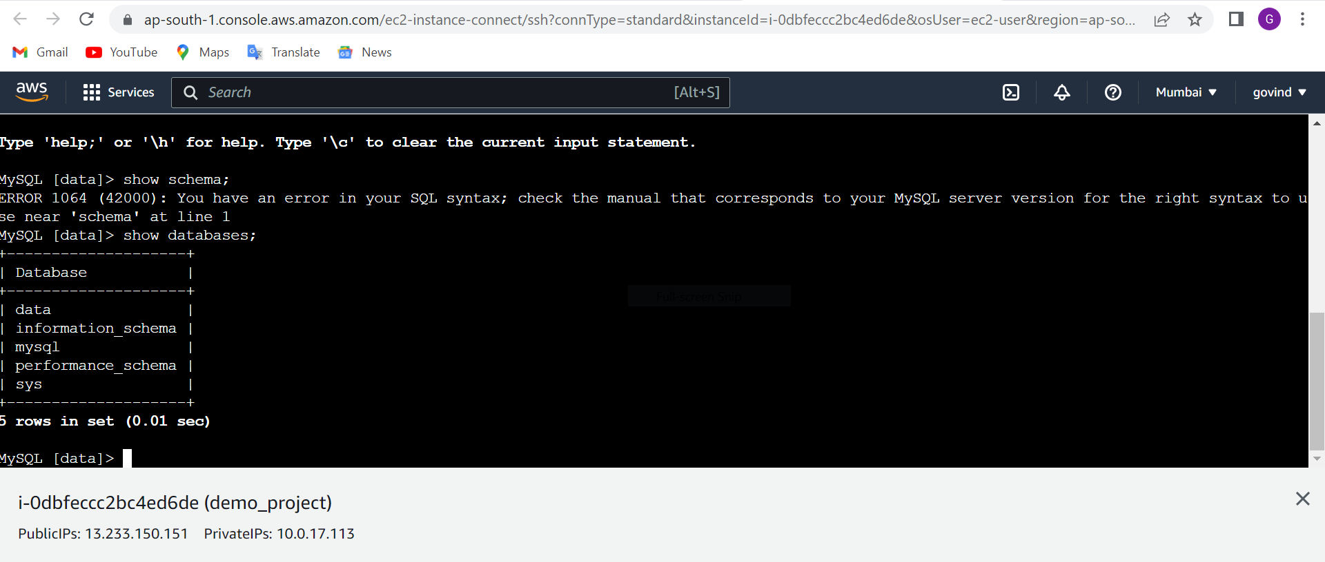

create schema created_schema_database;

show databases;

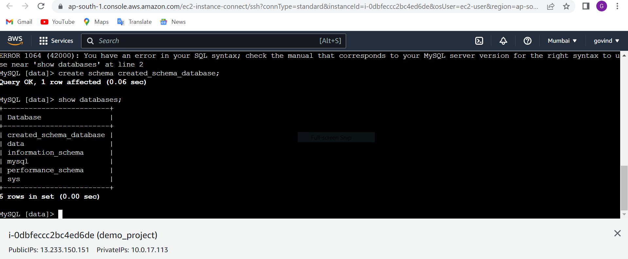

Use created_schema_database;

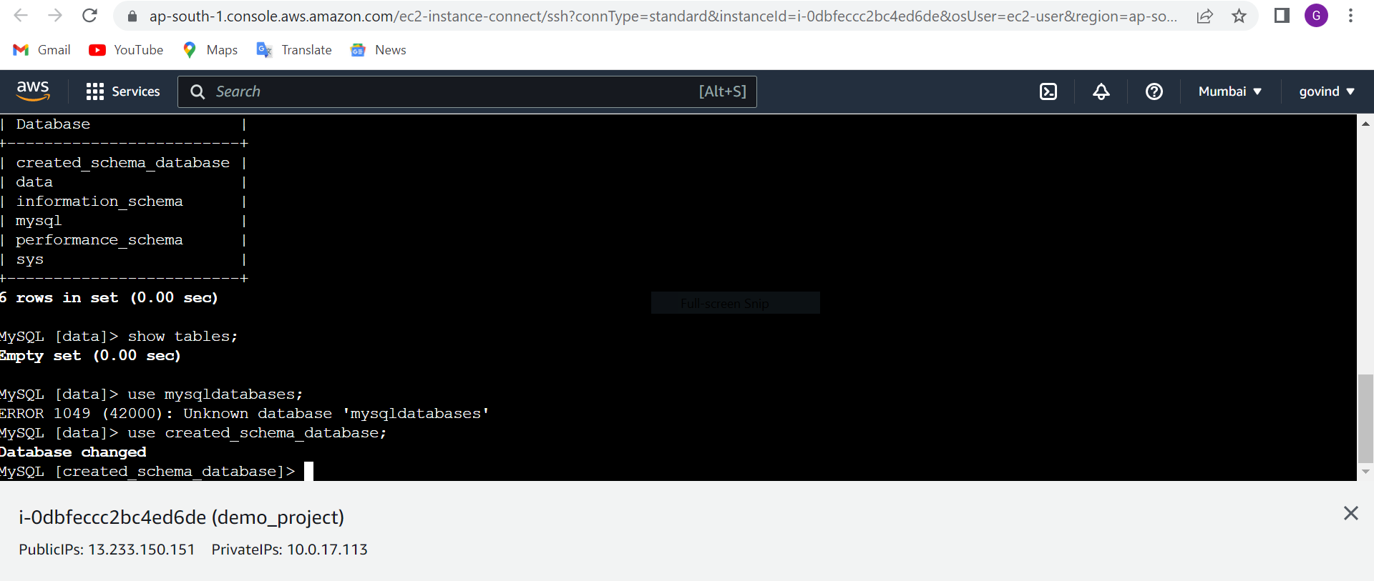

We created table and their column_names.

create table employees(Emp_id int, Emp_name varchar(200), Emp_designation varchar(200), Emobile_no int);

We have added the data in table.

INSERT INTO employees(Emp_id,Emp_name,Emp_designation,Emobile_no) values(01,'amit singh','Application developer', 2147483647);

INSERT INTO employees(Emp_id,Emp_name,Emp_designation,Emobile_no) values(01,'aniket mishra','Application developer', 2147483647);

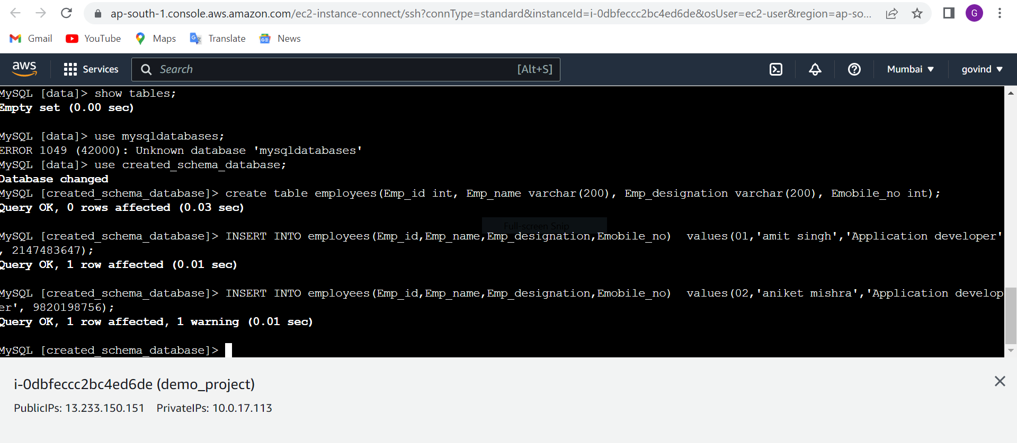

show tables;

select * from employees;

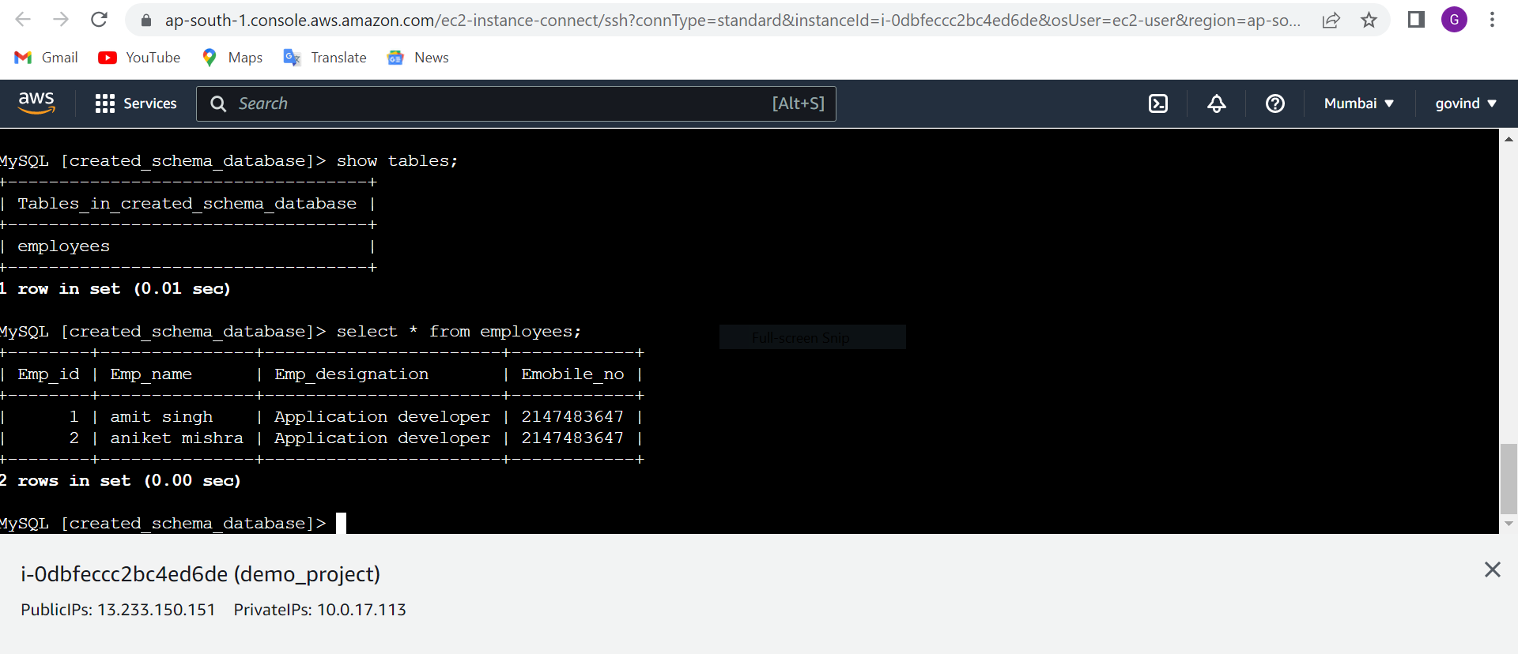

>>>>>>>>>>>>>>>>>>>>>>>>>>>>>>>>>>>>>done>>>>>>>>>>>>>>>>>>>>>>>>>>>>>>>>>>>>